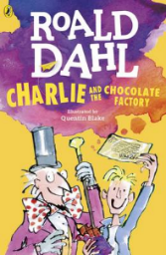
Charlie and the Chocolate Factory
Read Chapter 11 of the book or listen to it using this link https://www.youtube.com/watch?v=qCuNSZjCKg8

1) Listen to the story.
2) Discuss key questions.
3) Use the text to find evidence and answer the questions.

- Design your own Golden Ticket.
Make sure you include:
- To tell the person they are a winner
- Instructions for visiting Wonka’s factory and who to bring
- Signed from Willy Wonka

