WALT: understand different types of change w/c 29.6.20
Success Criteria:
I can identify different types of change
I can scale how I feel about different changes

This time of year is always a time of change, but this year this is truer than ever. Some of us are returning to school under strange circumstances, some are having school at home and we are all looking forward to becoming year 3s very soon.
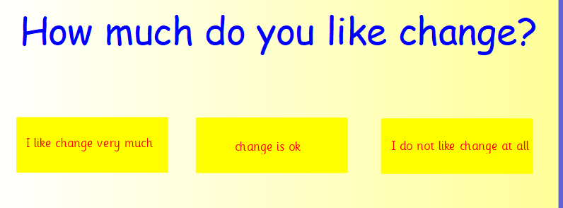

There are different types of changes. Some changes are unexpected, some changes are planned and some change is natural. Can you sort these different types of changes?
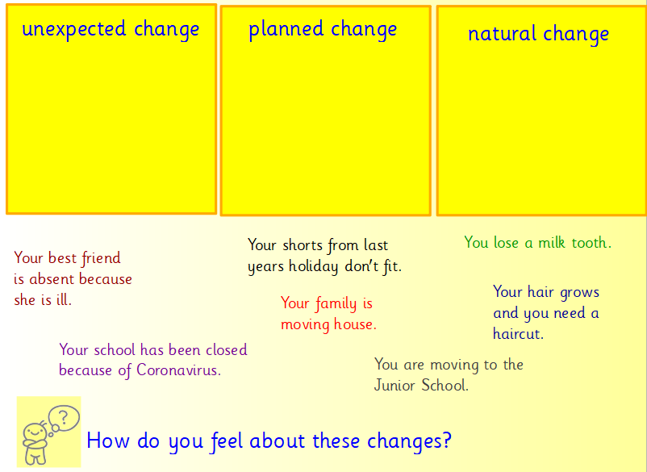

Can you think of any changes that have happened in your life recently?
Can you think of any changes that will be happening soon?

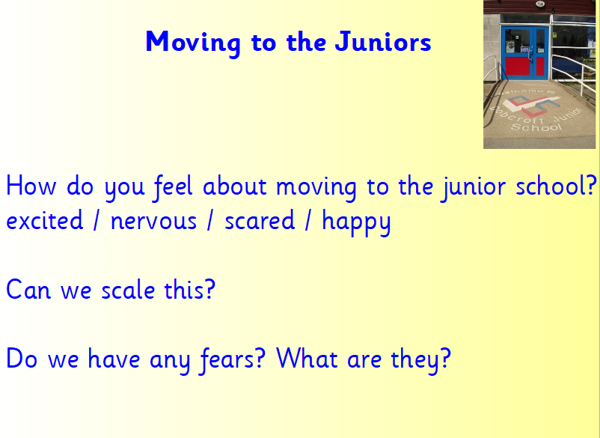

Task sheet
Can you think of some examples of different types of changes that have happened in your own life?
Planned change | Natural change | Unexpected change
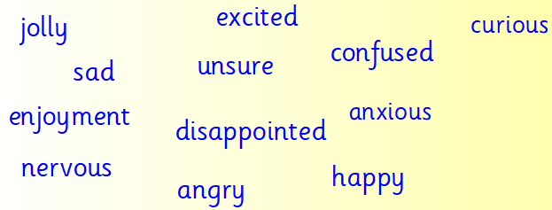
Can you choose one of your changes and explain how you feel about it and why? Use this word bank.

