Key Learning: to compare 2D and 3D shapes 1.7.20
Success Criteria:
I can describe different 2D and 3D shapes
I can compare shapes
I can identify 2D shapes that are faces of 3D shapes
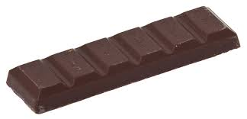
Independent

This is a new chocolate bar from Willy Wonka’s Chocolate Factory. Can you describe it?

_____________________________________________________________________

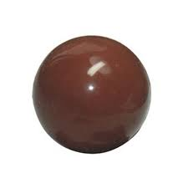
_____________________________________________________________________

Charlie found this piece of chocolate in the Chocolate Factory. Can you describe it?

_____________________________________________________________________

_____________________________________________________________________

Grandpa Joe has trouble telling the difference between these sweets. Can you describe the shapes to Grandpa Joe? What is the same and what is different about them?

_____________________________________________________________________

_____________________________________________________________________

_____________________________________________________________________

_____________________________________________________________________

