WALT recognise features of instruction writing 29.6.20
Success Criteria:
1.Decide which genre we are learning
2.Identify genre features on the WAGOLL
3.Find the SPaG features as a class
4.Highlight your own version of the WAGOLL with SPaG features

Task 1 – Practise & Consider
1.Match the section of the WAGOLL on the left to the feature label on the right.
2.Then order the pieces of the WAGOLL by writing numbers 1 to 4 next to each picture.
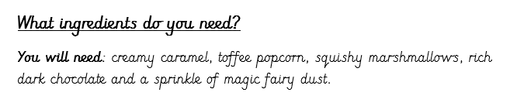
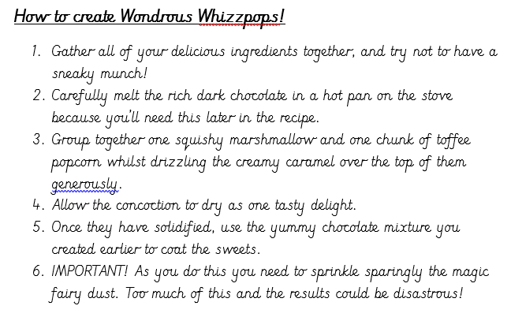
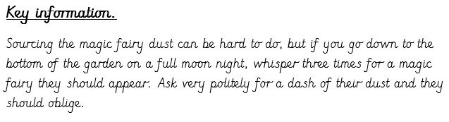
Check your work by looking at the WAGOLL provided!
HEADING
INGREDIENTS
INSTRUCTIONS BROKEN DOWN INTO STEPS
ADDITIONAL KEY INFORMATION

