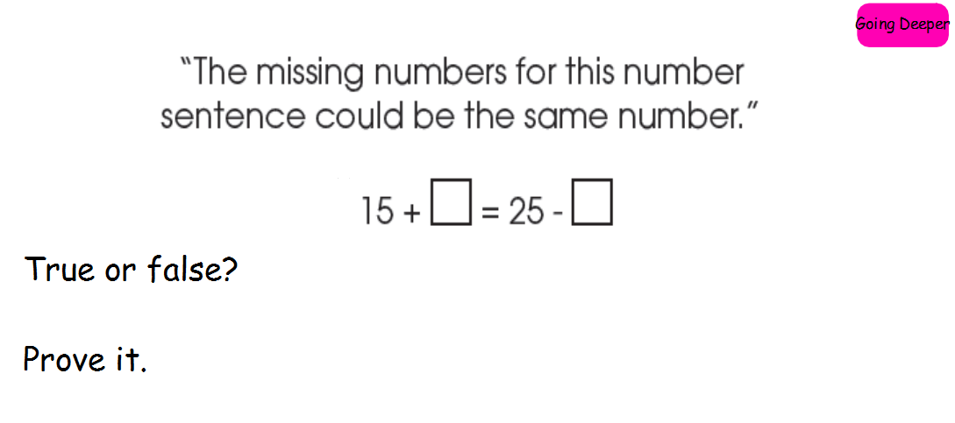

Both sides of the equals sign (=) need to be the same number, like a balanced scale.
15 + ___ must give you the same answer as 25 - __

