There are 65 children at Hill School.  17 children have a packed lunch.  Some children go home for lunch.  22 children have a school lunch.  How many children go home for lunch?  children | Adam makes a call from a telephone box.  He uses these five coins to make the call.  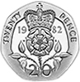  How much money has he got left from the £1?  p
There are 25 people on the bus. At 10 o’clock more people get on. At the next stop, 8 get off the bus. There are then 24 people on the bus. How many people got on the bus at 10 o’clock?  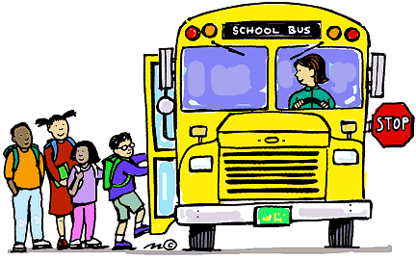  people | Alfie has 24 fish. One Saturday, he catches more fish. The next day 12 swim away. He then has 31 fish. How many did he catch on Saturday?  fish
Key Learning: to solve missing box word problems 24.6.20
Success Criteria:
I can identify the parts and whole in word problems
I can know which calculation to do to find the missing numbers
I can solve the missing box equation, and use the inverse to check my answer.

