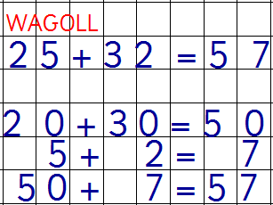
WAGOLL
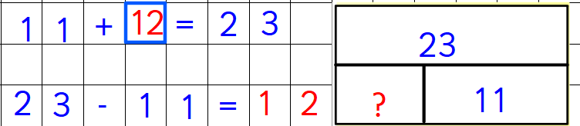
16 + ____ = 42

____ + 24 = 44

____ + 17 = 22

____ - 26 = 32

____ - 39 = 28

15 + ___ = 41

