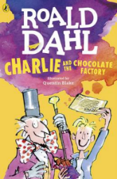
Charlie and the Chocolate Factory
Read Chapter 7 and 8 of the book or listen to it using this link https://www.youtube.com/watch?v=qCuNSZjCKg8

1) Listen to the story.
2) Discuss key questions.
3) Use the text to find evidence and answer the questions.

- How do you know Charlie and his family were nervous about him opening his chocolate bar?

- Match the child to the order that they won their Golden Ticket:

Veruca Salt 1st
Augustus Gloop 2nd
Mike Teavee 3rd
Violet Beauregarde 4th

- Page 39 -How did Mike feel about all the attention?
What evidence from the text tells you this?

