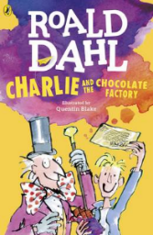
Charlie and the Chocolate Factory
Read Chapter 6 of the book or listen to it using this link https://www.youtube.com/watch?v=qCuNSZjCKg8

1) Listen to the story.
2) Discuss key questions.
3) Use the text to find evidence and answer the questions.

Describe this character using expanded noun phrases.
Use evidence from the text to back up your description.

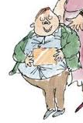

2) What did Veruca’s father do to ensure that she won a Golden Ticket?

