WALT punctuate sentences
1. Read the sentence
2. Use a capital letter at the start
3. Use a full stop (or end sentence punctuation) at the end
4. Add any other sentence punctuation that is needed
Deepen - Decide where your punctuation should go with a paragraph
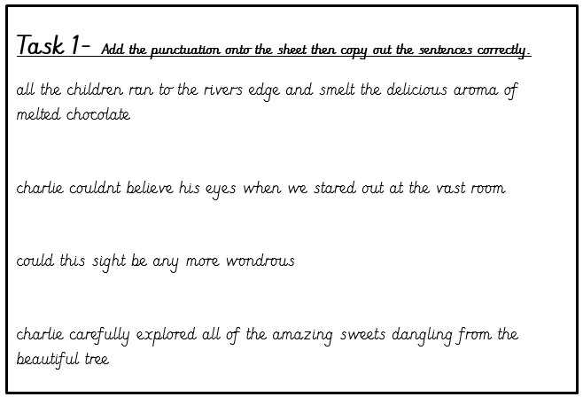

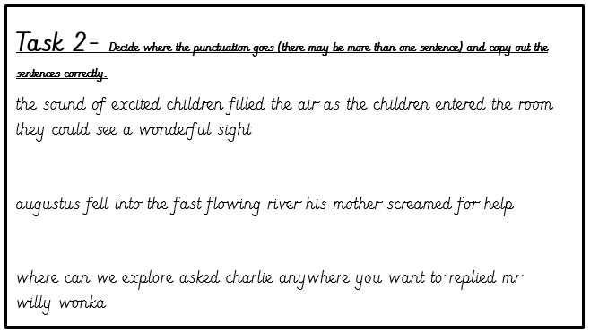

Challenge – Add in the punctuation in a paragraph
charlie crept through the enormous room the towering trees towered above him the children edged quietly into the centre of the valley excitement swished around charlies body the huge boat arrived the din was echoing through the entire factory charlie clenched his grandpas hand tightly the smell of chocolate caramel and fudge was overwhelming

