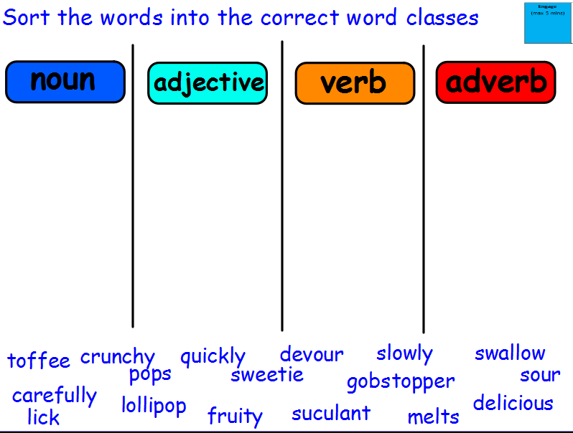
SPaG features checklist
Capital letters
Full stops
Expanded noun phrases
Co-ordinating conjunctions
Subordinating conjunctions
Question sentences
Exclamation marks
Suffixes
Correct tense
Spelling
Handwriting
Apostrophe for omission
Apostrophe for possession
Commas in a list
Writing for purpose

