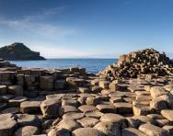
Learn about context of Northern Ireland first – Talk about the 4 countries of the UK (link back to Scottish day). Identify where Northern Ireland is. Look on Google maps. Have children been there? What did they see?

- MAP – can you create an outline of the UK and identify Northern Ireland (ensure they know the difference between Northern Ireland and Ireland)? What is the capital city of Northern Ireland? Year 1 can link to the launch of the Titanic.

- St Patrick’s Day is celebrated on 17th March in Northern Ireland (as well as the Republic of Ireland). Why and how do people celebrate? Create a poster or practical presentation to film.

- There are lots of famous people from Northern Ireland including authors and actors. Pick a famous person who originates from Northern Ireland and create a fact file about them. This could use your computing skills if you create a word document or power point!

- Group activity to collage the Ulster banner.
This can then be used as a poster background to put photos / artwork on as an end result of the days learning (photo of this could be added to twitter)
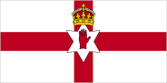
The only official flag in Northern Ireland is the Union Flag of the United Kingdom. The Ulster Banner was used by the Northern Ireland government from 1953 until the government and parliament were abolished in 1973.

- PE - Create your own Irish dancing routine (famous from the Republic of Ireland, but also very popular in Northern Ireland). Research and watch some Irish dancing on you tube.

- Food Tech – make Northern Ireland Farl (soda bread) For the children at home to try!
https://www.curiouscuisiniere.com/north-ireland-farl-soda-bread/

- DT - Create a famous Northern Irish landmark: The Giant’s Causeway.
This could be with scrapshed/outdoor equipment of a smaller T model created out of collected stones/rocks or art materials.
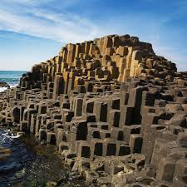
The Giant's Causeway is a famous rocky area of the coast in County Antrim. It's made up of thousands of hexagonal blocks of rock, formed by ancient volcanic eruptions.

