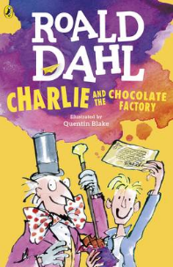
Charlie and the Chocolate Factory
Read Chapter 2 and 3 of the book or listen to it using this link https://www.youtube.com/watch?v=qCuNSZjCKg8

1) Listen to the story.
2) Discuss key questions.
3) Use the text to find evidence and answer the questions.

2. Why did the Prince's palace not last very long?
What happened to it?

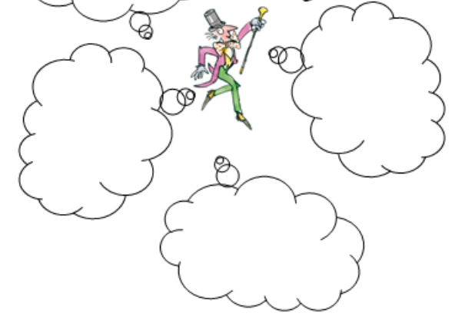
- What inventions did Grandopa Joe say Willy Wonka had made? Write 3 below:

