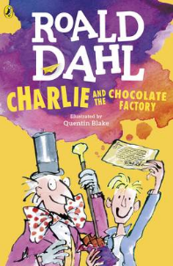
Charlie and the Chocolate Factory
Read Chapter 1 of the book or listen to it using this link https://www.youtube.com/watch?v=qCuNSZjCKg8

1) Listen to the story.
2) Discuss key questions.
3) Use the text to find evidence and answer the questions.

- Describe the Bucket house using 3 expanded noun phrases.

- Why did they all look forward to Sundays?

- Draw a picture of all the members of the Bucket family and add thought bubbles for what each character might be thinking at the start of the story.

