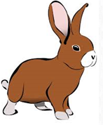
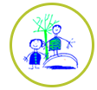
Daily challenges
Choose in any order and see if you can complete them all. Send pictures for us to share on the website or twitter.
Take a virtual tour of an aquarium.  How many fish do you see?  https://aqua.org/media/virtualtours/baltimore/index.html  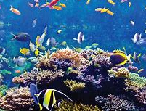 | Learn a new dance with Oti.  https://www.bbc.co.uk/iplayer/episode/m000jsf1/otis-boogie-beebies-series-1-1-zoom-to-the-moon | Go for a walk, carefully look in a pond. Can you see any animals?  Draw one and write a sentence about it.  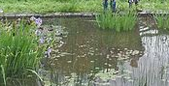 | Make fish puppet, can you tell a story with them?  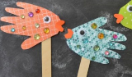
Ring a friend or grandparent and read your favourite book.  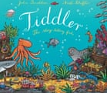  Listen to mine,’ Tiddler’ https://www.bing.com/videos/search?q=tiddler+story&docid=608012458109701610&mid=813D9EADD9EB2AB3BAFD813D9EADD9EB2AB3BAFD&view=detail&FORM=VIRE | Under the sea  Put cushions or pieces of paper on the floor/ground. Play the music ‘Under the sea’ and pretend to swim in the ocean, when the music stops get to safety on a cushion/paper.  https://www.youtube.com/watch?v=GC_mV1IpjWA | Read or listen to the story ‘The Rainbow fish’  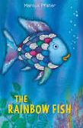  https://www.youtube.com/watch?v=QFORvXhub28  Can you retell the story to an adult? | Listen to Ralph Vaughan Williams, A Sea Symphony. Which instruments can you hear? Draw a picture as you listen.  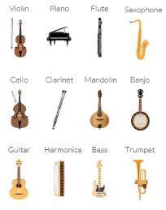  https://www.cmuse.org/classical-music-inspired-by-water/
Draw, colour or paint lots of fish. Can you make an aquarium on a window for people to see or an aquarium plate?  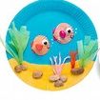 | Clamming for marbles  Fill a paddling pool with about 20cms of water and add marbles (can add sand too). Children walk in the paddling pool to find the clams with their toes. | Beach bag relay  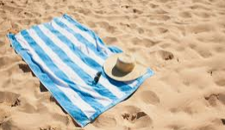  Fill a beach bag with suncream, hat, sunglasses, towel and a book. Take it in turns to run to the end of the garden and set up the beach equipment. Who can do it the fastest? | Make a dessert aquarium using blue jelly and fish sweets.  