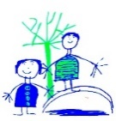

**Other Curriculum Areas:**

**PE:** Gymnastics – applying balances and travelling onto apparatus. Games – net games.

**Personal, Social, Health Education:** Staying Healthy – How we keep our bodies healthy and understanding that sometimes we get ill.

**Art:** Sculpture. Creating imaginary animals out of clay inspired by Nikki Saint De Phalle.

**Computing:** digital writing. Exploring using a keyboard, adding and removing text and making changes when typing.

**Geography:** Recap what the countries of the UK and their capital cities are. Link to St George’s Day.

**RE:**

Buddhism: To introduce Buddhism and to be able to describe 4 facts about Buddhism.

To listen to the story of The Monkey King and discuss kindness.

To listen to meditation music and relaxation skills.

**Star Words:**

Buddhist Monk Temple Meditate

Nun Special Book: Tipitaka

**Maths and English:**

**English Text:** Molly Rogers Pirate Girl.

Key date: April 26th – Pirate Dress Up Day

Writing genres: write a story, animal non-fiction fact files and independent story writing.

**Maths:** Number and place value within 50. Adding and Subtracting within 50. Measure – length and height.

**Science:**

**Key Knowledge:**

Animals including humans: To identify and name a variety of common animals. To describe and compare the structure of a variety of common animals. To identify common animals that are carnivores, herbivores and omnivores. To be able to identify, name, draw and label the basic parts of the human body and associated sense.

To observe changes across the four seasons.

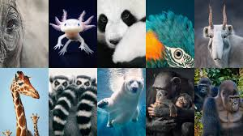

**Star Words:**

Name, identify, classify, carnivore, herbivore, omnivore, fish, amphibians, reptiles, birds and mammals, senses, body parts, wings, fur, feathers, claws, tail. Spring, blossom, bloom, flower.

**History:**

To understand the lives of significant individuals within History – David Attenborough and Jane Goodall

 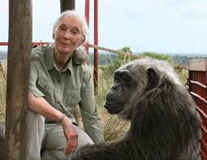

**Star Words:**

Significant, individual, national, international, contribution.

**Key Knowledge:**

To understand the lives of significant individuals who have contributed to the national and international achievements.

**Roars, Paws and Claws – Summer 1**