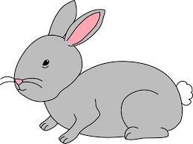
Home Learning Challenge 2/6/20
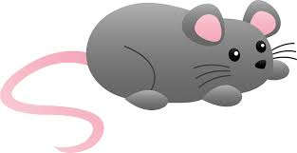
Challenge 1 – Time!
Practise reading the time to the hour.
Say the time out loud “The time is 6 o’clock”
Where are the hands on the clock positioned?
Can you make your own clock using a split pin and
set the time.
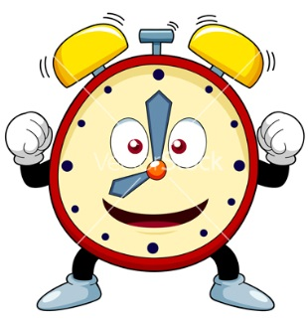
What time will it be in one hours’ time?
Have a go at playing “What’s the time Mr Wolf” with your family.
Extension
Can you tell the time to half hour?
Where are the hands positioned?
Can you draw the hands on the clock to show the time to the hour and half hour?

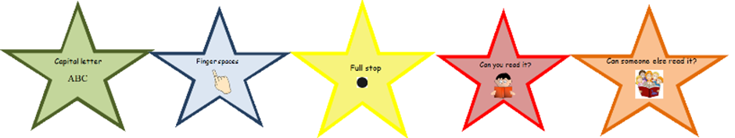
Challenge 2 – Can you describe your best day?
Imagine you woke up and you could do whatever you wanted for a day!
What would you eat? Where would you go?
Maybe you would choose to eat sweets for breakfast and then take a rocket in to space!
Use your imagination to describe what your day would be like.
Try and extend your sentences using a conjunction.
You could then imagine what your very word day would be like. Maybe you would have to eat slugs for breakfast!
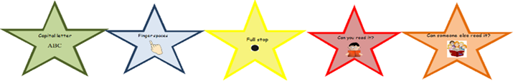
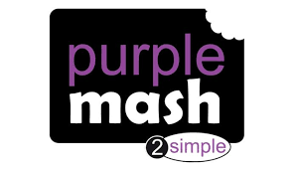
Purple Mash
Use the art tools on Purple Mash to illustrate your best day ever!
Remember your teachers will be able to see your work.

