Summer Term 1: Week 6
History task: research a significant person from the past

All the news coverage of Captain Tom Moore and VE Day recently got my thinking about significant people in history and how we remember them. For your history task this week, I’d like you to research a significant person from history who has contributed to national or international achievements. This could be a member of the royal family, an artist, an explorer, an inventor, or someone who stood up for people’s rights for example.

On Purple Mash there are lots of options of different people you could choose. Follow the steps below:
Click ‘Topics’
Click ‘Famous People’
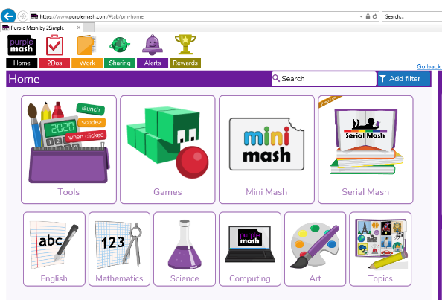

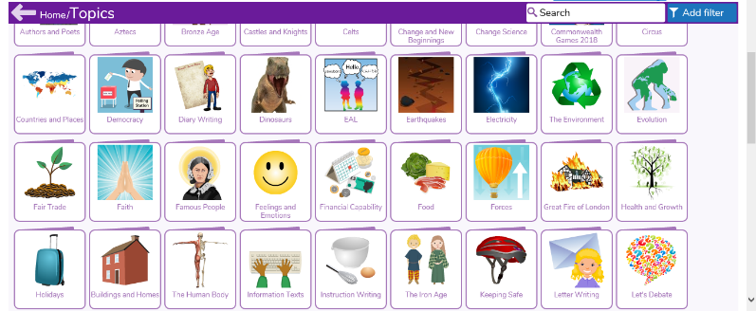

Choose your category and then your significant person to research.

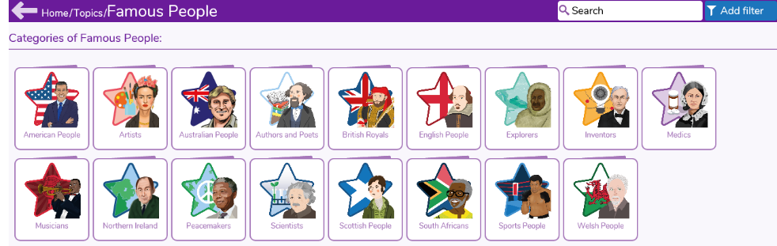

What 3 questions would you ask your significant person?
Write these down, with a question mark (?) at the end of each question.

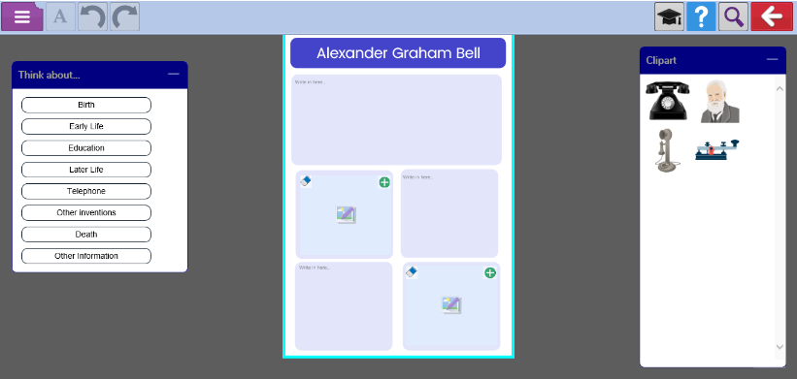
Then research your significant person and write a fact file about them.
See the example fact file from PurpleMash below:
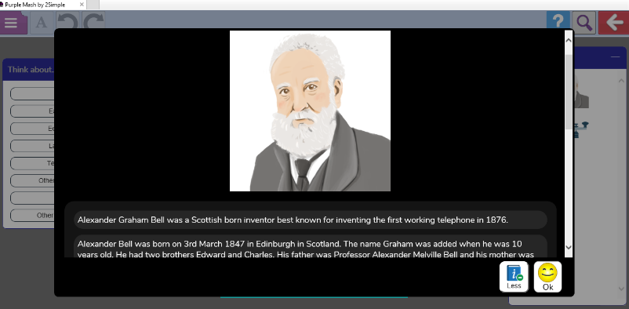
Hover your mouse over a subheading for question prompts.

Can’t wait to see which significant person you learn about!

