Summer Term 1: Week 6
English – Activity 1
Hi Year 2,
We hope you’ve had a lovely weekend with your families.
This week, we would like you to some research into a Scottish Landmark of your choice, and create an advert for that landmark to persuade people to go and visit it. Your advert could be in the style of a leaflet, a poster, or another format you wish to do it in. Remember to make your advert as colourful and eye-catching as possible!
Your advert must include:
- The name of the landmark you are researching.
- A catchy headline to draw people in.
- A picture of the landmark.
- Reasons why they should visit this landmark.
Here are a few Scottish landmarks in case you are struggling to find them:
- Edinburgh Castle, Edinburgh.
- Loch Ness, Scottish Highlands.
- Loch Lomond and the Trossach’s National Park, Scottish Highlands.
- Ben Nevis – Scottish Highlands.
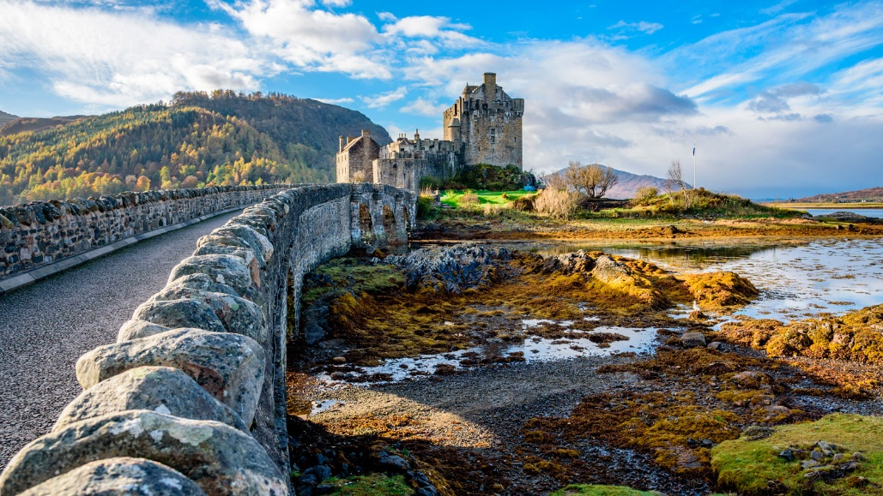
- Arthur’s Seat – Edinburgh.

Challenge – Can you go back and edit your work? Check for your SPaG features. Have you included alliteration, powerful adjectives, coordination/ subordinating conjunctions, speech marks?

