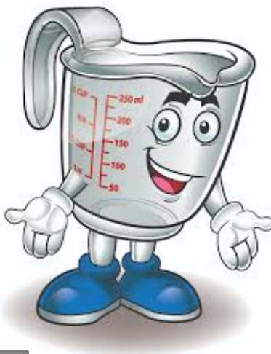
Summer Term 1: Week 6
Maths – Activity 4
It’s our last maths session for the week! You did lots of great work yesterday looking at scales, so know we are going to put that into practise!
You will need:
- 1 measuring jug
- 5 containers of different shapes and sizes (cups, glasses, yoghurt pot, bowl etc.)
- Water

Fill your measuring jug up with 500ml of water.
We need to evenly share the water between the 5 containers that you have chosen.
Pour water into each container, estimating the amount you will need so that each one is equal.
When you have done this, you can pour the liquid from each container into the jug to see how much you actually measured out (make sure you do this one at a time so that you can record each amount).

Then think about the following questions:
- How accurate were your estimations?
- What made it difficult to compare the amounts in each container?
- Is there a strategy you could use to be more accurate next time?

Once you have thought about these questions, have another go and see if you get closer! Then try the same with these amounts:
- 200ml
- 1 litre
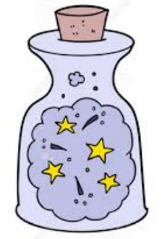
CHALLENGE TIME!
LET’S MAKE SOME POTIONS! Can you create some exciting potions for us? All you will need is some water and food colouring – the colours are totally up to you!
- Choose 2 colours (ideally a light and a dark colour).
- Decide how many ml of each ingredient (colour) you would like to put into your potion.
- Think carefully – what do you want your potion to look like? Will that affect how much of each colour you put in?
- You can experiment as many times as you like to see how many different potions you can make! Why not give each of them a cool name! What will that potion do if you drink it?
Take a picture of your potions (make sure you write on a piece of paper the amounts that you added) and send it in to us! We will then put them on the Dobcroft Twitter page for everyone to see!

