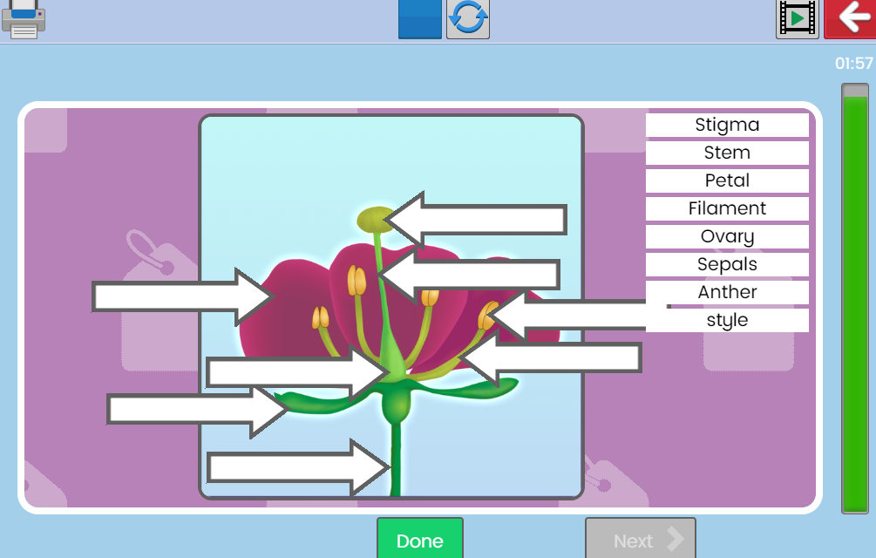
Labelling the Life Cycle of a Plant

