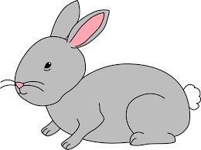
Home Learning Challenge 18/5/20
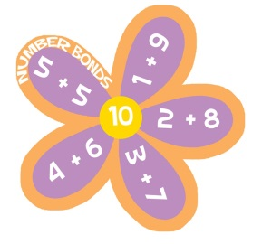
Challenge 1 – Making a given total!
Count out a set of 10 objects.
How many different ways can you share them out between two bowls?
Write down a number sentence to show your arrangement e.g. 4+6 = 10
How many different ways can you find?
Make it fun! Make your own spider or Octopus. Can you find eight different ways to make 8? Write your number sentences on the legs of your creature.
Extension
Can you use addition and subtraction to make your target number?
Can you make your total by adding more than two numbers?
Do you know the number bonds to 10 by heart?
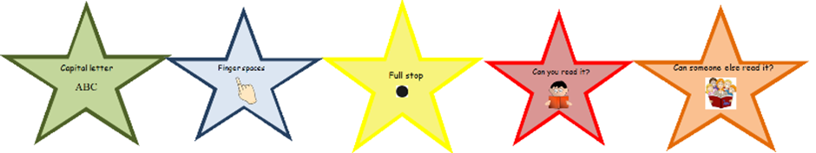
Challenge 2 – Write a new story!
The children have practised retelling stories and last week had a go at innovating a familiar story. Can you now write a new story of your own?
Pick a character, Pick a setting and decide on your problem.
Choose an exciting story start: once upon a time, one sunny day, along time age…
You could make it exciting by writing in a real book.
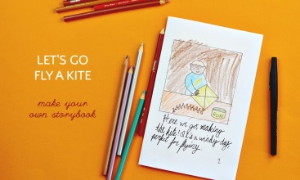
You could give your story a front cover and illustration too.
Remember to check your work using the writing stars.
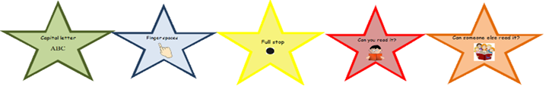
Purple Mash
Try using story creator (in tools) to write your story.
Your teachers will then be able to read your work!

