one | two | three
four | five | six
seven | eight | nine
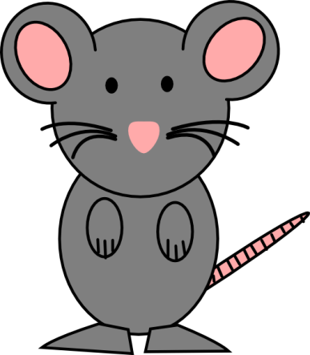
Spelling Zapper 9
Practise reading, wri words below.
ting and spelling aloud the When your children can read, write and spell the words below put a “Z” in the corner of the word.
When they have 4 spelling zapper

