WALT: Find quartering of an amount
Work completed: independently small group support 1:1

Draw dots in the boxes to find a quarter of each amount.
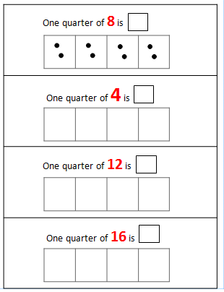
Fill in the box to complete the quartering sentence.

