Summer Term 1: Week 3
Maths Activity 3 – Calculation
Task 1 -Warm your brain up!
Answer these calculation questions as quickly as you can. Can you answer find the answers mentally, without using your fingers or drawing?
3 + 2 = | 7 + 1 = | 3 – 1 = | 9 + 9 =
10 – 4 = | 5 + 5 = | 2 + 7 = | 11 – 4 =
9 – 3 = | 9 – 6 = | 5 – 4 = | 7 + 6 =
1 + 6 = | 5 + 4 = | 8 + 4 = | 12 – 3 =
5 – 2 = | 6 – 4 = | 9 + 6 = | 2 + 4 – 3 =
8 + 8 = | 2 + 8 + 3= | 3 – 1 -1 = | 6 + 4 + 5 =
7 – 7 = | 9 – 2 – 3 = | 4 + 9 + 1 = | 5 + 3 – 1 =
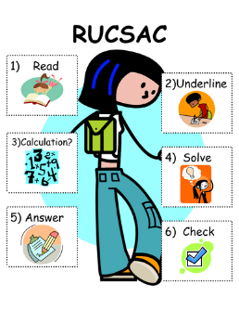
Task 2
Can you solve the word problems using RUCSAC to help you? Remember to use all of the calculation strategies to help you to solve the equations, and check your answers carefully!
I had 15 sweets. I gave 7 away. How many have I got left now? | I had 16 toy cars. Steve gave me 13 more. How many toy cars have I got now? | We bought 19 cakes. I ate 4. How many cakes have I got left?
The blue team scored 18 tries in the first half and 14 more in the second half. How many tries did they score altogether? | A tub contains 52 sweets. Sam takes 15 sweets. John takes 21 sweets. How many sweets are left in the tub? | There are 25 ducks in the pond. 17 geese fly into the pond. How many ducks and geese are there altogether?
Dan needs 80g of sugar for his recipe. There are 45g left in one bag and 20g left in another. How much more sugar does he need? | Together Jack and Sam have £12  Jack has £2 more than Sam  How much money does Sam have? | Yesterday the temperature was 26 degrees. The next morning it was 5 degrees colder and 11 degrees colder in the evening. What was the temperature in the evening?
Task 3

Bubble gum
Strawberry
Vanilla
Chocolate

Mrs Holmes is spending a lot of her time at home eating ice cream! She has 4 different flavours in her freezer but can only fit 2 scoops of ice cream on each cone. How many different combinations of ice cream can Mrs Holmes make?
For example:
Vanilla + Strawberry
Vanilla + Chocolate
…..

What if I found another flavour lurking in the back of my freezer? How many different combinations could I make with 5 flavours of ice cream?

