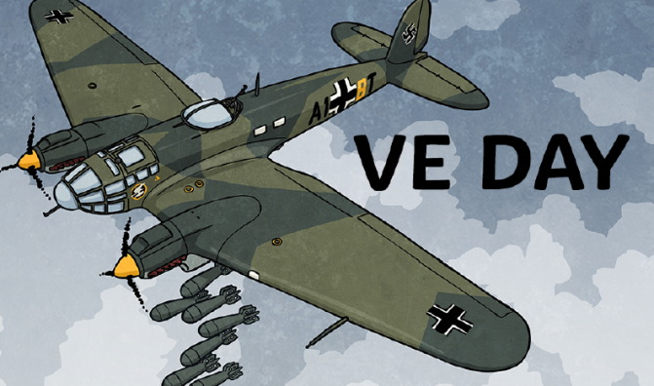
Summer Term 1: Week 4
Topic Activity 2: History (VE Day)
On Friday 8th 2020 we all celebrated the 75th anniversary of VE Day! But what is VE Day all about? Well let’s find out.
What is VE Day?
VE Day stands for Victory in Europe Day, and is celebrated on 8th May. It marks the day towards the end of World War Two when fighting against Nazi Germany ended in Europe. Although it was not the end of the Second World War, it was the end of the fighting in Europe.

How Did It Happen?
In April 1945, Hitler died. This meant that the Germans had to surrender their part in the Second World War. The German president of The Third Reich (the German Army), gave orders that General Jodl should go to the American army headquarters in France and surrender to the western and Russian officers.

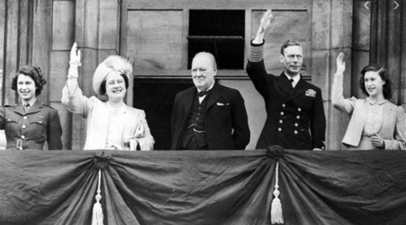
The Announcement
The British Prime Minister, Winston Churchill, made the following announcement at 7:40pm on 7th May 1945: “In accordance with arrangements between three great powers, tomorrow, Tuesday, will be treated as Victory in Europe Day and will be regarded as a holiday.”
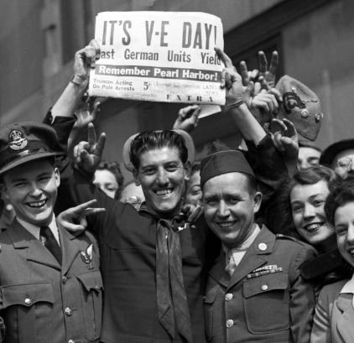
Bring On The Celebrations!
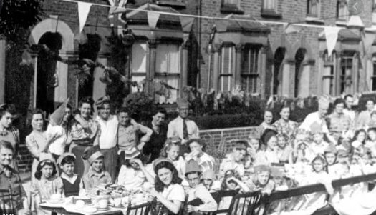
The British people began celebrating as soon as they heard the news. People began decorating the streets with banners, bunting and ribbons. They had street parties and shared food with their neighbours. Huge crowds, with many people dressed in red, white and blue, gathered outside Buckingham Palace in London. They cheered as the King and his family came out onto the balcony to greet everybody. Fireworks filled the sky with flashes of light, and bonfires were set alight to celebrate (people had not been allowed to light a bonfire for 6 years due to the war).

NEWS FLASH!

Now let’s transport ourselves back to 8th May 1945. Winston Churchill has announced the surrender of the German army, and everyone is taking to the streets to celebrate! It is a very happy time. How do you think you would feel hearing this news after your country has been at war for the past 6 years? Your food has been rationed, your home may have even been destroyed, and you’ve not seen friends and family properly in a long time.
You are a news reporter who has been asked to describe the celebrations that are taking place.
Write a news report, giving details of the events that have taken place the day before (7th May) and the celebrations that are taking place now. (Later you will be using this writing to make your own news report video so let’s make them as exciting as possible!) Use the information you have been given as well as your own research. Here are some pieces of information you could include:
- Why did the German army surrender?
- Who made the announcement?
- What members of the royal family came out to greet everyone?
- How are people celebrating?
- How does everyone feel?
REMEMBER: You are writing as if you are actually there in 1945. So you will need to write in the present tense.
When you have finished, make a recording of yourself performing your report out loud as a news reporter – just like you would see on the news! You can be as creative as you like with this! What do you need to do with your voice to make your video exciting? Can you include some props, costumes or pictures to make your report even more realistic?
When you have finished, send it in to us at Dobcroft. We would LOVE to see them!

