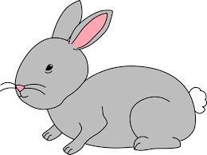
Home Learning Challenge 11/5/20
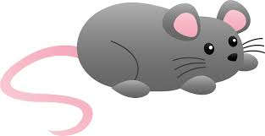
Challenge 1 – length
Explore length by direct comparison.
Ask the people in your house to stand up. Who is the tallest and who is the shortest? Can you stand in height order?
Choose favourite toy. How many things can you find that are longer or shorter? Can you find anything that is of equal length?
Choose 6 different objects (ribbons, lolly sticks and straws work well). Compare their length using a common starting point e.g. you could make a masking tape line to measure from. Can you put the objects in order of length from the longest to the shortest?
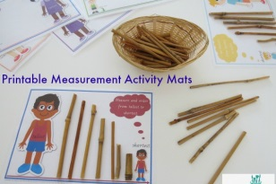
Use different pieces of paper and fabric; can you glue the pieces in height order?
Extension
Use a ruler to measure different lengths in cm.
Can you draw a line of a particular length?
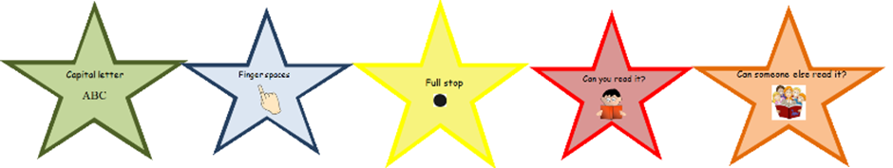
Challenge 2 – Innovate a familiar story!
The children are very familiar with the Gingerbread Man story. Listen to the story of the Runaway Pancake. How is it the same/ different?
Can you think of a new story based on a different runaway food?
Draw your own story map to show what will happen in your story. Have a go at writing your new story using story book language.
Check and improve your work using the writing stars.
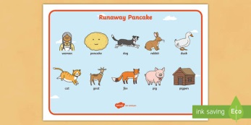
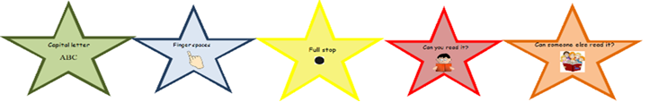

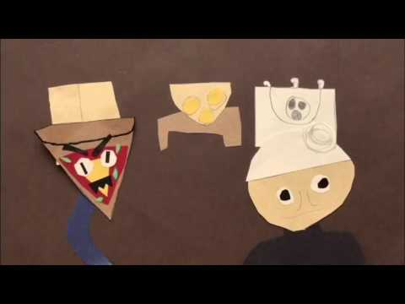
Challenge 3 – Make a Film
Can you make your own props to tell your story?
Ask someone to film you.
Have a premiere and share your film with friends and family!

