Rabbits Blog 04.05.2020
Hello Rabbits!
Happy Star Wars Day for those of you that like it! If you do anything to celebrate, then please send a photo to me and I will post it here!
This week there have been lots of busy rabbits sending me their pictures!
Arman sent me lots of photos:
He’s been planting peas and writing the instructions!
He and his sister made pizza for Italy Day, they made a bug hotel, and Arman made friends with a goat! What a busy week! And what amazing writing! Keep going Arman – you’re working so hard!
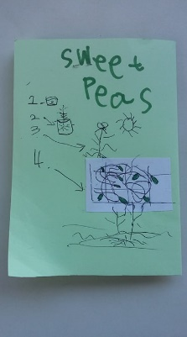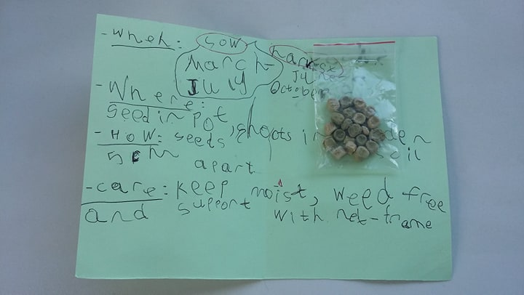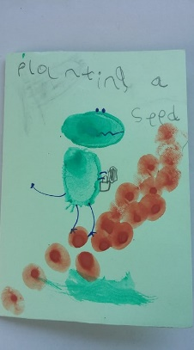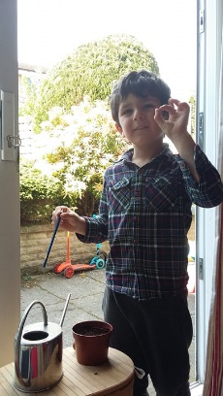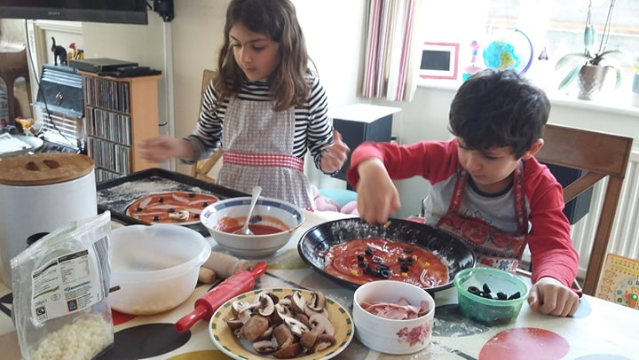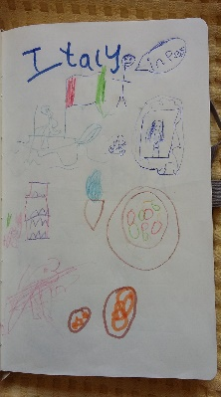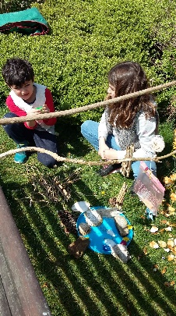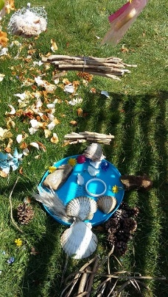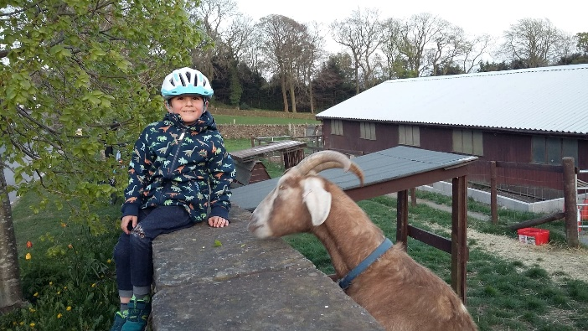

Frances has started collecting snails. I’m waiting to see if she sends me a picture of them… Do you like snails?

Hrishi and his brother have made bird feeders using coconut oil and seeds and they have hung them near their new nesting box in their garden.

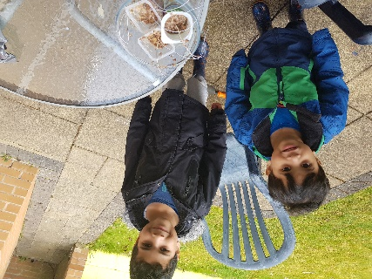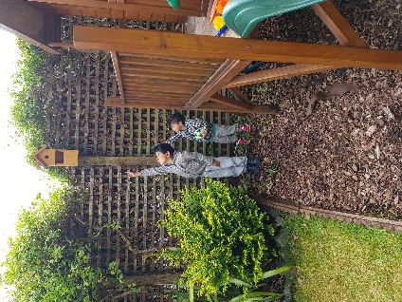

This week I have been watching this bit of my garden wall….
Some coal tits have made a nest in the hole in the wall and they fly in and out of it to feed the babies! I can’t believe they can fit through the hole, but they can! I will try to catch a photo but it’s very hard as they are so fast!
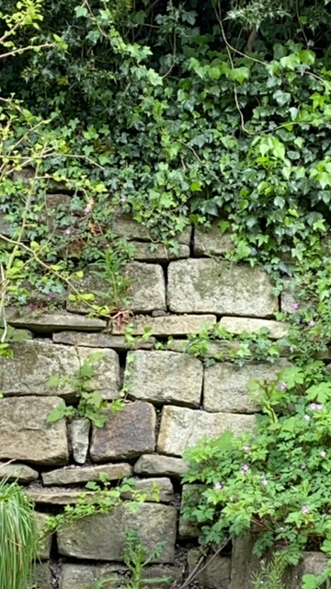
The adults fly in through this tiny hole and you can hear the chicks inside cheeping!
This is what a coal tit looks like.
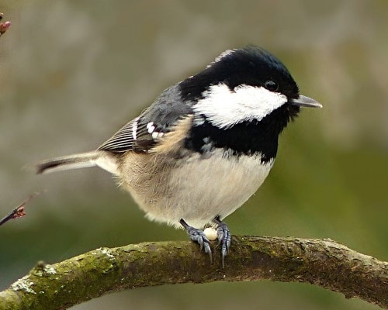
I went for a walk and saw some amazing clouds. Can you see the rainbow on the last one?
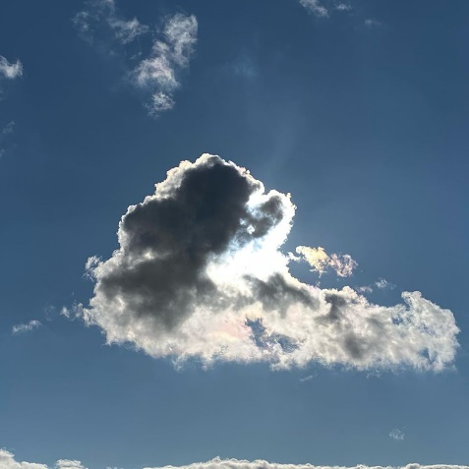
My husband got me a new present off the internet. It’s a lens that you take photos through:
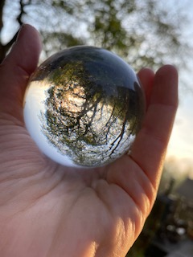
Can you see what 3D shape it is? Do you remember what it’s called? Can you see that it turns everything upside down?
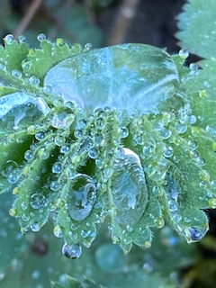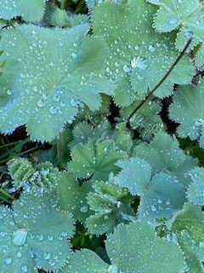
All day on Thursday it rained. At the end of the day, the sun came out and I went outside with my camera. Look at the raindrops trapped in the hairs on these leaves!
Then I saw these drops on these petals and this leaf. They look a bit like my photography sphere!
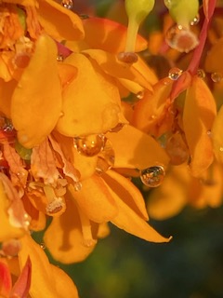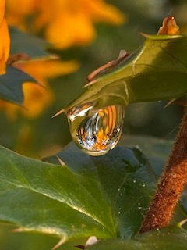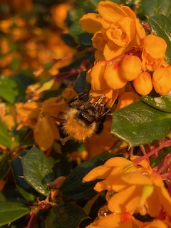
The last photo is of a bumble bee having a drink of nectar. I like his furry body, like he’s got a jacket on! Look at his long tongue! Why do you think it’s so long? What does it help him to do?
Have a great week – listen to the bedtime story this week – it’s ‘Off to the Fair’ By Christopher Wormell. Check on Friday for the next one!
Stay safe and keep eating your carrots, Rabbits!
Love from Mrs F xx

