Summer Term 1 Week 3:
Design Technology: food tech, healthy diet and where food comes from

Since working from home more, Miss Hughes has been baking and cooking lots of new foods to try. Normally, she is not the one to make the meals in her house, but she’s trying!
Miss Hughes has realised she really likes banana muffins and katsu curry, but she doesn’t like pancakes with raisins in or salmon.

Task:
Not all food we eat is grown in England. Watch the PowerPoint about where around the world some of our food comes from.

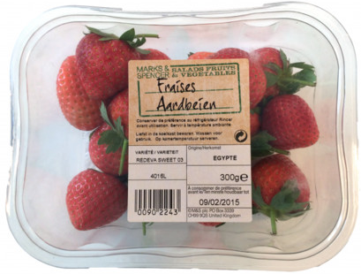
Can you look on any food packaging in your house to see where the food you’re eating comes from?

If you look closely on the label, it says these strawberries were picked in Egypt!

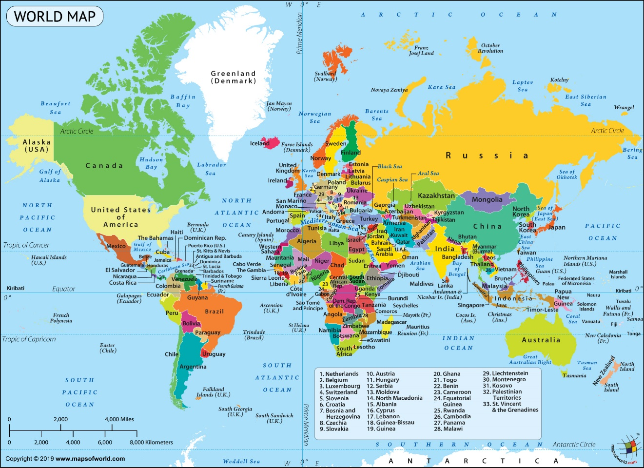
If you have a map at home or using the one below, can you find the different countries your food has travelled from?

