Summer Term 1: Week 3
Maths Activity 3 – Times Tables

LET’S PRACTISE OUR TIMES TABLES!
Follow the video below to practise your 2 times table.
https://www.bbc.co.uk/teach/supermovers/ks1-maths-the-2-times-table-with-bridget-the-lioness/zrrx92p
Follow the video below to practise your 10 times table.
https://www.bbc.co.uk/teach/supermovers/ks1-maths-the-10-times-table-with-webster-the-spider/zm32cqt
Follow the video below to practise your 5 times table.
https://www.bbc.co.uk/teach/supermovers/ks1-maths-the-5-times-table/zhbm47h

Task 1
Can you think of your own creative way to show your 2, 5 and 10 times tables? Try to be as imaginative as you like! You could go out into the garden and use chalk or skipping ropes to create a grid. Or what about making multiplication flowers! Here are just a few ideas to get you started.
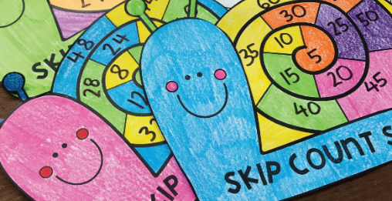
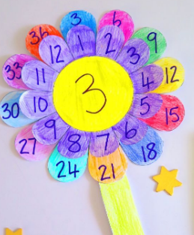
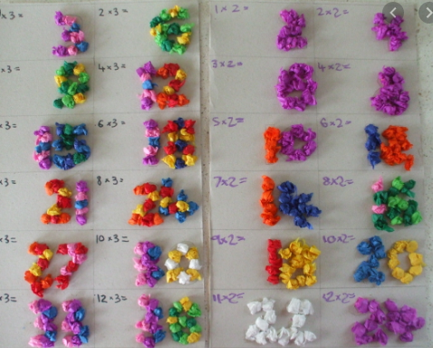
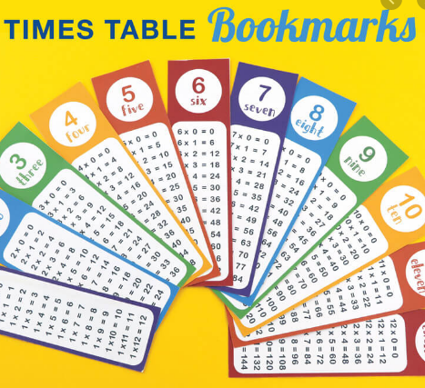
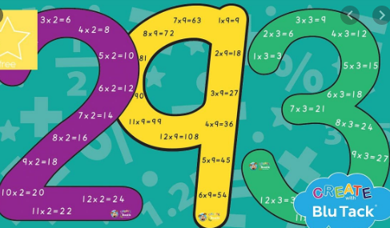

CHALLENGE: Now include your 3 times table!
Task 2: Now let’s see if we can combine our learning about money with our times tables!
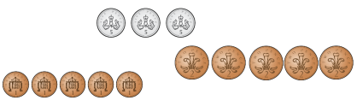
Count in your times tables to work out how much is in each set of coins.

Use or draw coins to show the given amounts below.
- 10p in 2p coins
Challenge: Can you estimate how many coins you will need before counting them out? How does your times table knowledge help you?
- 45p in 5p coins
- £1 in 10p coins
- 70p in 10p coins

Challenge 1 Challenge 2
