Summer Term 1: Week 1
Maths Activity 3 – Money (Problem Solving)

We have done some great work so far this week on money! Think about what we have done over the last two days – what do you feel you have got better at? What do you feel you might need some more practise with?

Have a go at this video to recap our learning from the last few lessons!

https://www.bbc.co.uk/teach/supermovers/ks1-maths-money/zht4nrd
Task 1
HOW MUCH CHANGE? If a question is asking you how much change you will get, you need to find out how much money will be left over after buying the item. To work this out we need to use – SUBTRACTION.
For example:
Mrs Rowland buys this loaf of bread. She uses a 50p coin. How much change will she get?
50p – 40p = 10p
the amount of the cost of the amount
money Mrs Rowland the item of change
paid with
40p

Now it’s your turn! Make sure you write out the calculation you used to find the answer.
Mrs Machin buys this carton of milk with a 50p coin. How much change will she get?
34p

Miss Hughes buys this packet of apples. She pays 30p. How much change will she get?
18p

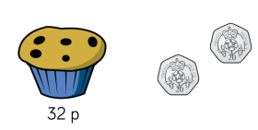
Mrs Holmes buys this muffin with these coins. How much change will she get?

Task 2
Now try these questions (it’s nothing new). Make sure you read the questions carefully as there may be a few extra steps!
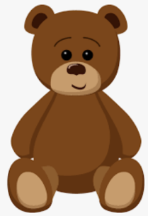
Elliot buys this teddy bear at the charity shop. He pays £5. How much change will he get?

£2
REMEMBER! 100p = £1
Sarah buys 2 bananas and one bunch of grapes from the supermarket. How much change will she get if she pays with a £1 coin?

8p
42p

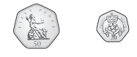
Challenge
Dora has these coins.
She spends 53p.
What money will she have left? What coins could it be?

Task 3
Let’s create a shop! Find items in your house that you would like to “sell” to your family (we are not really going to sell them! Just pretending...but shhhhhh, don’t tell anyone yet!) Give each item a separate price and let members of your family come and buy items from your shop.
Can you give them the correct amount of change?
What addition or subtraction could you use to help you?

Take a picture of your shop and send it in to us at Dobcroft on your teacher’s email! We LOVE to see all your amazing learning.

