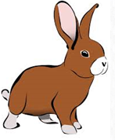
Daily challenges
Choose in any order and see if you can complete them all. Send pictures for us to share on the website or twitter.
Make some fruit ice lollies or ice cubes, use juice and fruit. How creative can you be? | Draw a plant  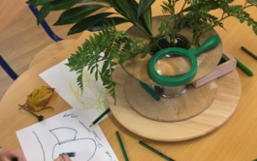 | Make a marble run using a tray, playdough and a marble.  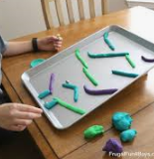 | Play a game.  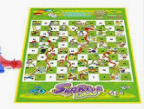  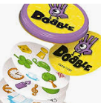
Plan an obstacle course and draw it in chalk on your path outside your house.  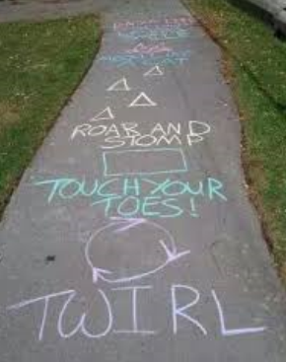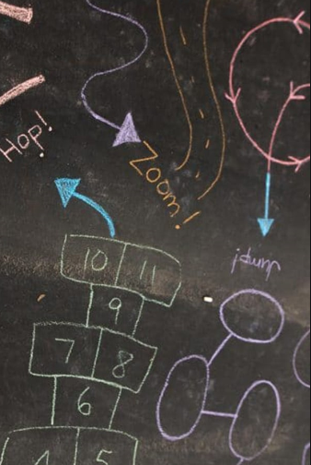 | Bake buns or biscuits, can they be from a story book?  The very helpful hedgehog  The gingerbread man | Sing a Andy’s animal rap  https://www.bbc.co.uk/teach/bring-the-noise/andys-raps-index/z6tjcqt | Read a story to a family member over the telephone, facetime or Zoom.
Can you make stick or lollipop puppets and tell a story.  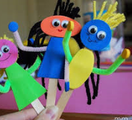  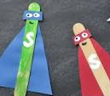 | Draw all of the different things you saw on your walk/bike/scooter ride today. | Listen to a book on audible or an e-book on Oxford Owl website (https://home.oxfordowl.co.uk/). | Mindfulness  