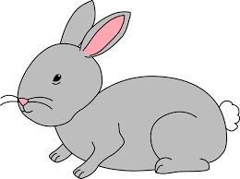
Home Learning Challenge 4/5/20
Challenge 1 – Mixed operation Problems
Generate your own number sentences to make learning more fun!
Collect two bowls. In one bowl put number cards 1- 12 (or you could use two dice) in the other bowl put cards with the operation signs + -.
Children to pick two number cards from the first bowl and then choose an operation sign. Children to then create their own number sentence e.g. 6 + 4 =
Remind the children to put the larger number first.
Have fun solving the problems using a chalk number line outside or jumping up and down the stairs.
Can the children read their number sentence? Is it an addition or subtraction problem? Do they know which way to jump on their number line?
Extension
Can the children write the opposite problem e.g. 3+7 = 10
10 – 7 = 3
Can you solve a number puzzle?
Give your child 3 numbers
5 | 12 | 7
Can they cut them up and arrange them to make a number sentence, writing in the operation signs? Test it using a number line, is it correct?
Write a recount!
Mrs Godwin has made a video for you to watch of the blue bells in the woods. You could visit the woods too to see the bluebells or maybe you have some in your garden or local area. You could take a clipboard or camera with you to record any signs you spot along the way.
Can you write a recount of a walk you have been on? What did you see? Where did you go? How are the woods different from our trip in the Autumn and early spring?
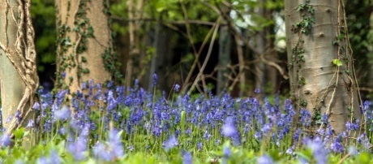
Check and improve your work using the writing stars.
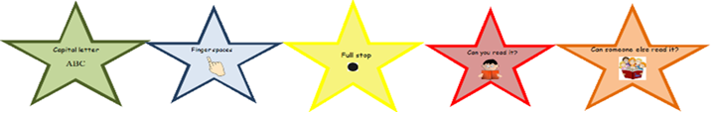

Challenge 3 – Make a mobile
Watch the clip to see the frogs born changing. What do you know about the life cycle of a frog?
Can you make your own life cycle mobile?
Choose two sticks and tie them together. Can you draw four pictures to show the life cycle? Hand one picture from each end of the stick.
