Hello Foundation stage!
I have had problems uploading this blog this week so sorry it is late.
This week I have had some photos from children to show me their learning. You’ve been so busy! Can you see yours?
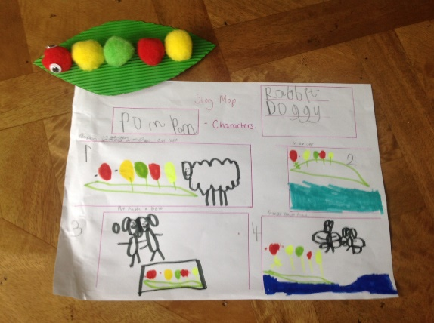Abigail’s fantastic story map and caterpillar! |  | 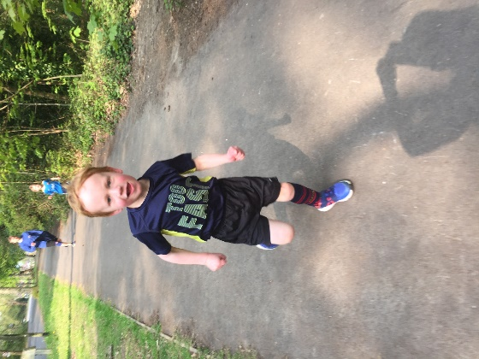  Cory took part in the Dobcroft Dash!
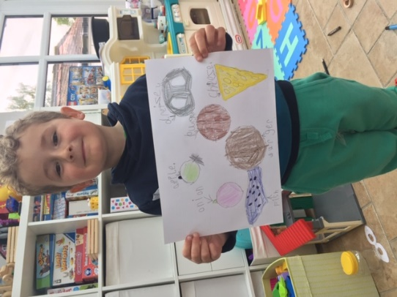  Patricks writing and drawing! So neat and easy to read! |  | 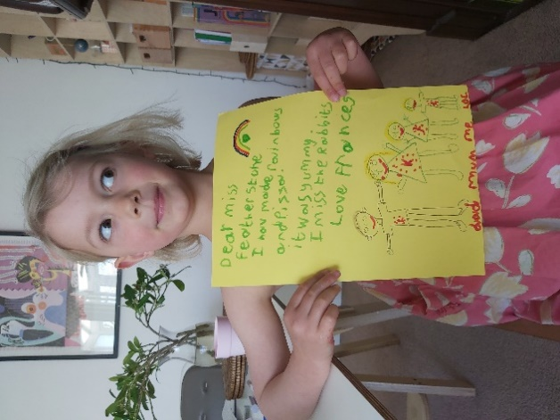  Frances’ super writing to Mrs F!
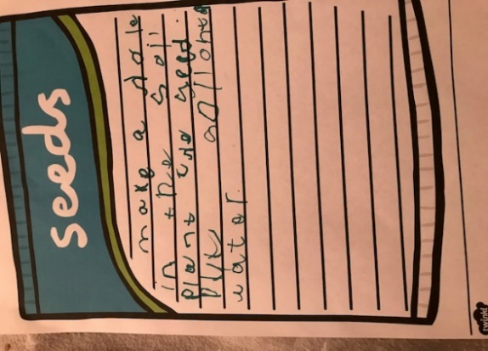  Fifi wrote instructions for planting a seed! |  | 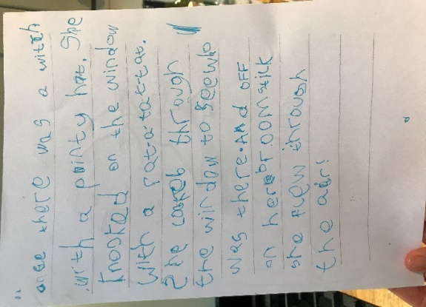  Harry wrote about a witch (I think I can guess which book he’s been reading – can you?)
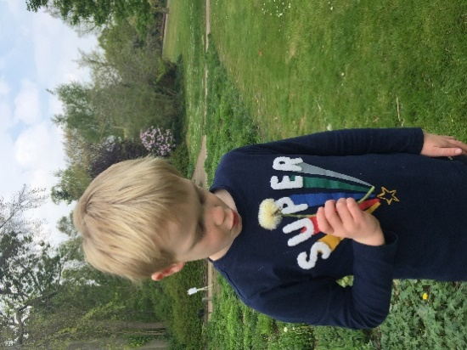  Max has been looking at nature! Can you see what he’s found? |  | 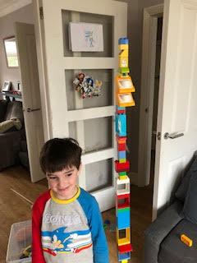  Look at Leo’s massive lego tower. I reckon it’s a Leo and a half tall… Can you build one as tall? Or taller?

Here are some interesting things I have looked at, growing in my garden.

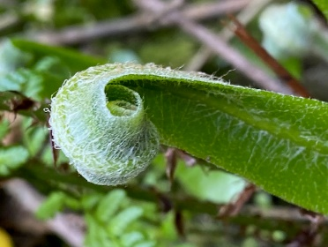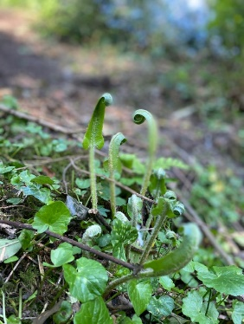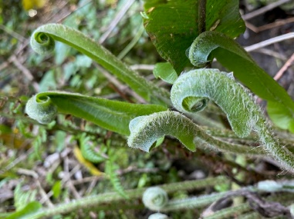
These are ferns and they are growing – can you see how the leaves are curled up inside as they grow? They will be long and thin when they have opened out.
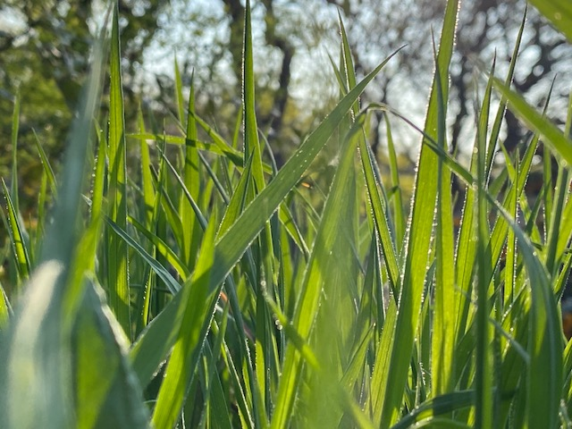
This is what grass looks like if you are a mouse or an ant….!
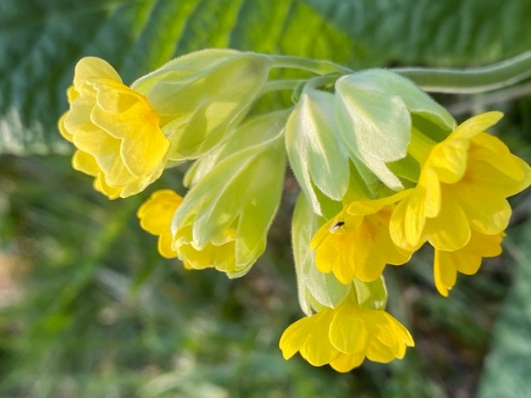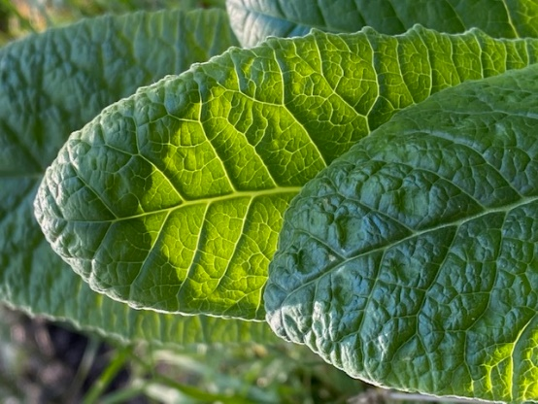
These are cowslips – what a funny name! Look at those leaves - I bet a rabbit would love to eat those! Can you see the tiny fly on the flower? And the sun coming through the petals and the leaves?
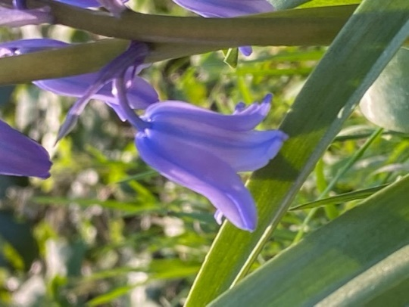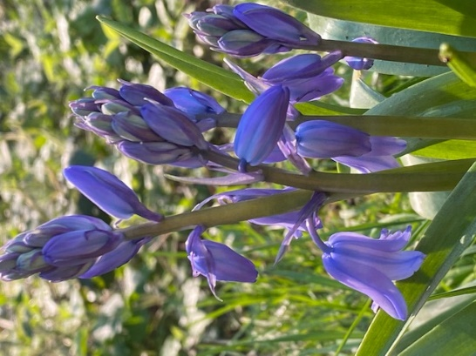
These are bluebells. There are loads in the woods at the moment. The bees love them. They smell really beautiful.
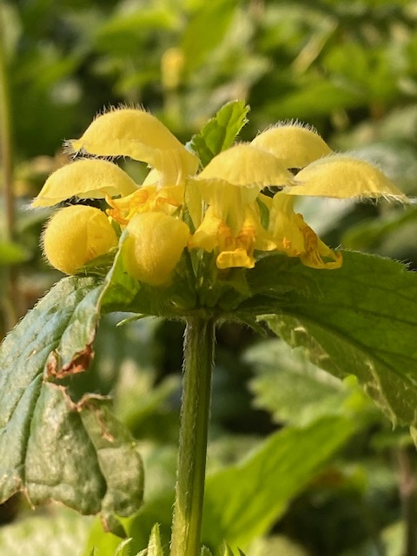
These are wild flowers and they are called Archangel. Look closely - can you see the hairy petals? These flowers are shaped so that when the bee lands on the bottom petal, the flower opens up so they can get at the nectar. They’re called snap dragons because they look like dragon’s mouths and they snap shut!
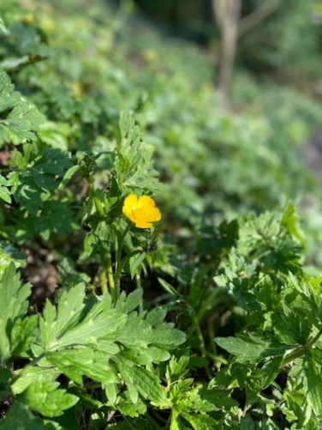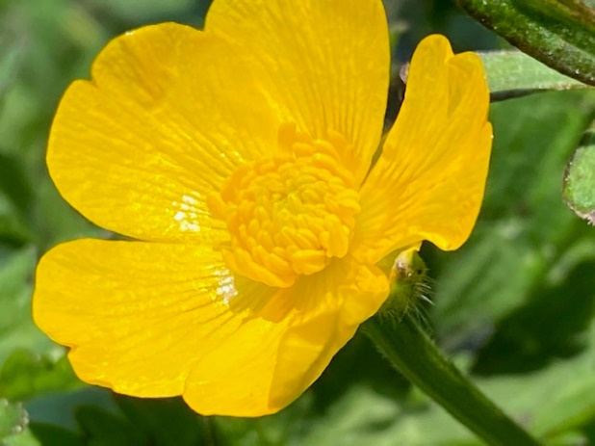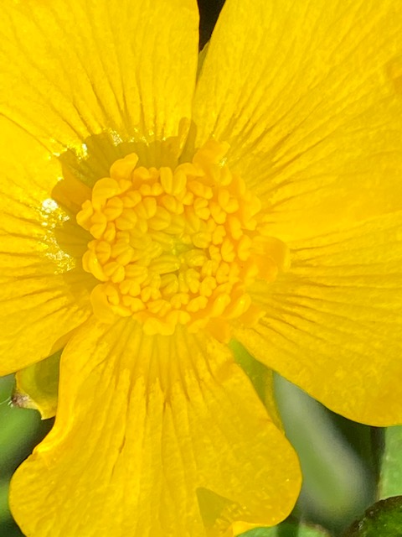
This is a buttercup. Have you ever looked really closely at one? Can you see how shiny the petals are? And those lines on the petals look different to a bee. They show it where the nectar is (a sweet juice in the middle of the flower). While the bee is drinking the nectar, the pollen, which is like dust on those bits in the middle, gets all over their hairy bodies and they collect it to make honey. When they go to the next flower some dust from one flower get onto the next flower and the flower can then use it to make seeds or fruit.
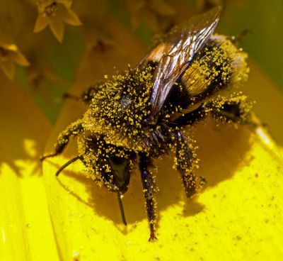
This bee has pollen all over her! (I know it’s a girl because girls do all the gathering work in the bee world)
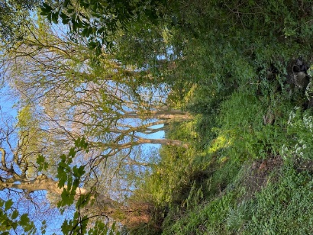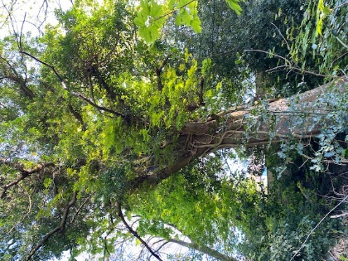
The leaves on the trees are coming out… Everything is turning green!
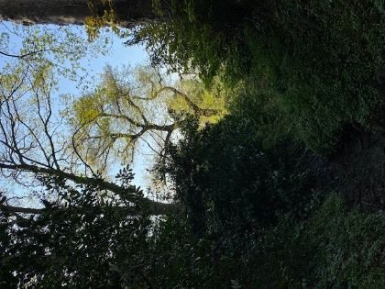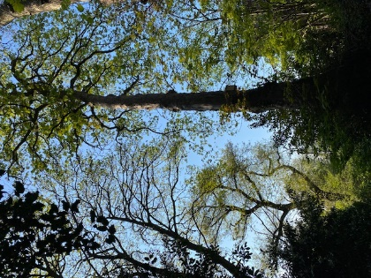
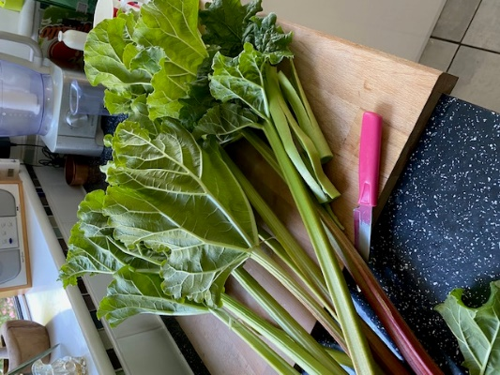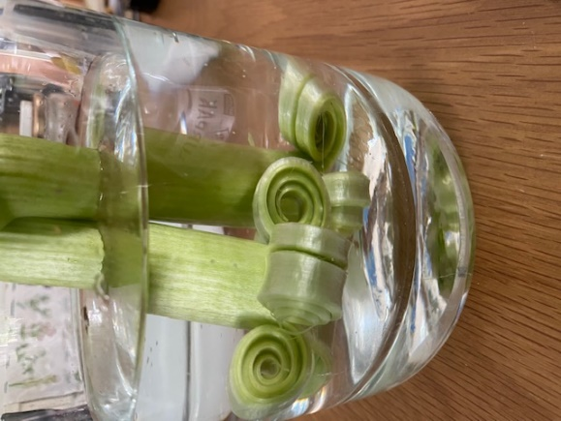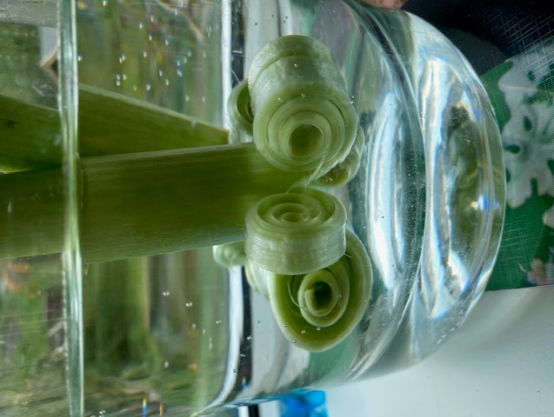
I cut some rhubarb from my garden and I cut the flowers off and put them in a vase. The flowers are a bit boring – but look what happened to the stems! They were straight like the rhubarb in the first photo when I put them in the water they went all curly! Amazing!
Mrs Lambert made flap jack this week. It looked delicious. If you want to make some, you can use this recipe:
https://www.bbcgoodfood.com/recipes/yummy-golden-syrup-flapjacks
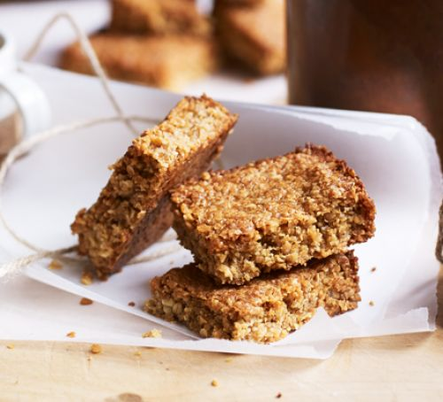
There are lots of print off activities on the website from last week, and Mrs Choudhry is regularly updating the activities, so there should be lots for you to do.

The theme day in school tomorrow is Mexican. They are having a pinata and making dip to eat with tortillas. They will also be doinfg some mexican crafts. Heres a good website.
https://feltmagnet.com/crafts/mexican-crafts-2
Have a great time and stay safe!
Mrs Featherstone and all of the Foundation Stage Team. xx

