Hello Rabbits!

I haven’t been able to upload my blog this week because the website kept causing problems, but hopefully this will work as I am trying it a different way!
Firstly lots of people have been sending pictures to me so I will show you those first as they are lovely!
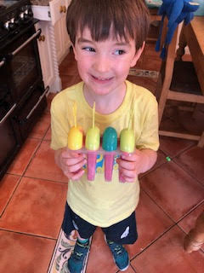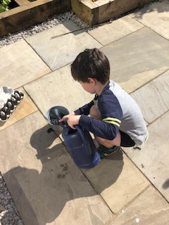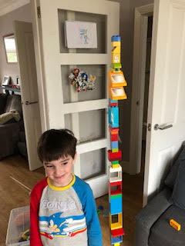
Leo has been building with his lego! Look how tall that tower is! It’s as big as one and a half Leos! He also has been planting in the garden and making ice creams! Delicious!
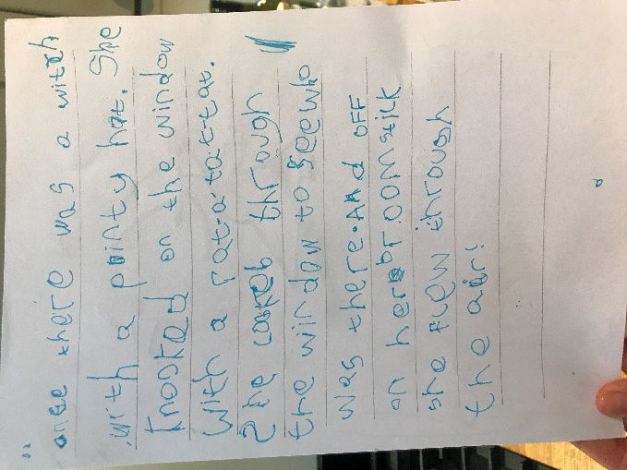
Right – get your amazed face on, because this is Harry’s writing! Wow! He has clearly been practising really hard and making sure he catches all the sounds in a word so that we can read it. Amazing work Harry! SO much writing too! Keep going.
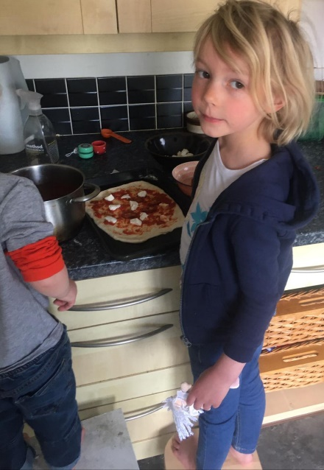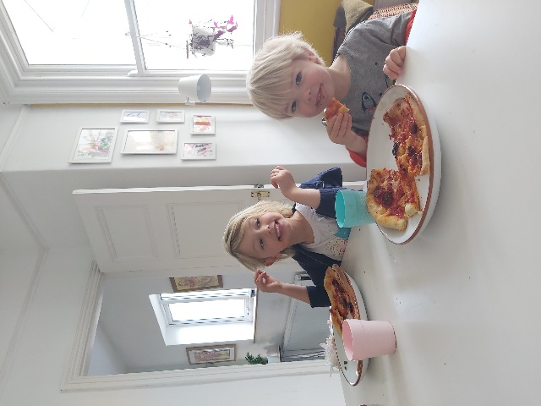
Frances and her brother made pizza on Thursday for part of the Italian theme day at school. It looks very nice. It’s making me hungry!
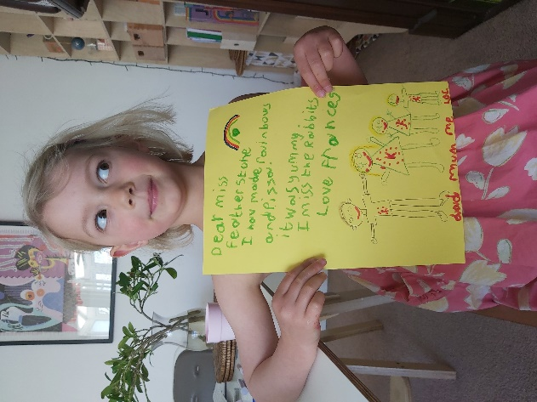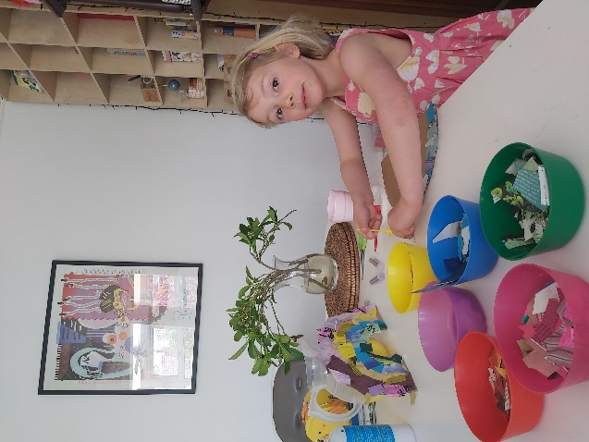
She then did some collage (I love that rainbow!) and some fantastic writing to me! Well done Frances, you have been very busy.
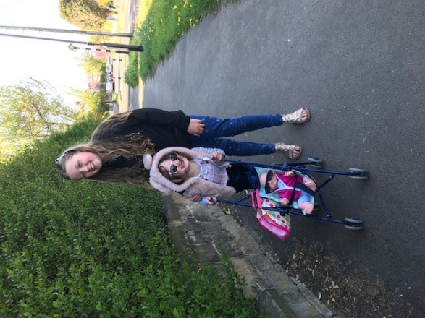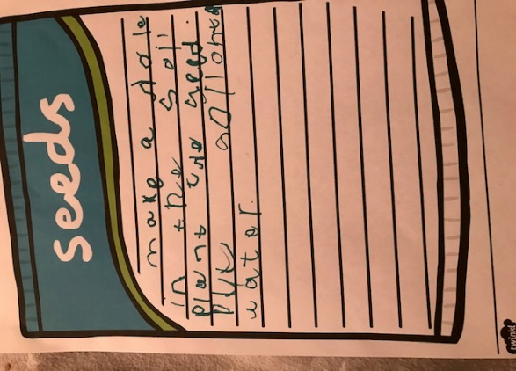
Fifi went out for a walk with her and then planted seeds and wrote up the instructions! Great work Fifi. Now if you want to do it again next year, you will remember what to do!
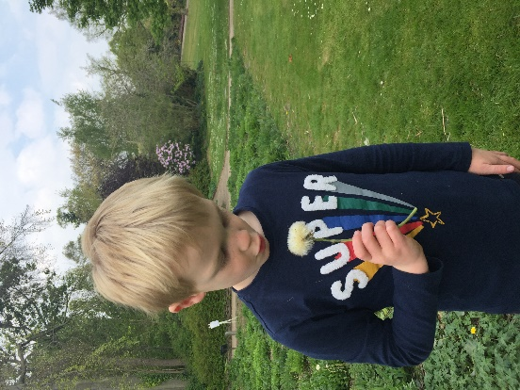
Max has been out looking at nature and found a dandelion clock. How many blows to make all the seeds fly off Max? Was the dandelion clock right?
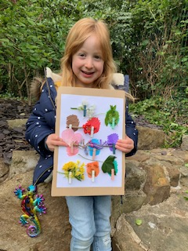
Now this is a brilliant idea. Ruby sent this picture of her activity she did on her walk. She painted some colours onto a piece of card and then stuck some clothes pegs on, and then the challenge was to find things on the walk that are the same colour as the paint splodge. What a great idea! And you can stick it on your wall as a picture when you get home! Then if you want to do it again, you can take the things off and do it again on your next walk! Well done Ruby. Which was the hardest colour to match?
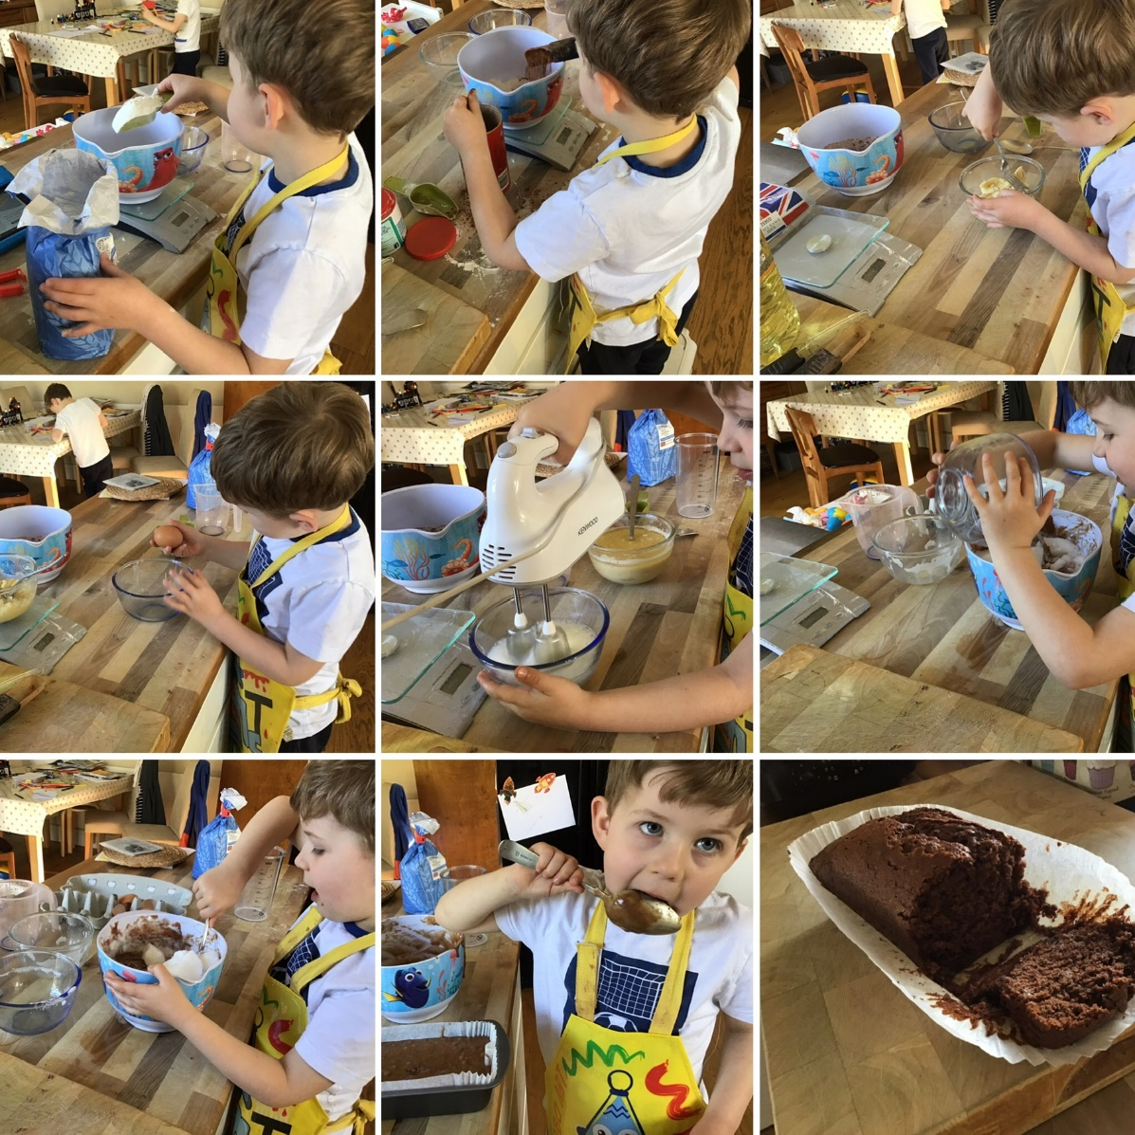
William made a chocolate cake. Can you see the ingredients he used? It looks absolutely delicious! I made a cake the other morning and I got to lick the spoon for my breakfast! (I don’t recommend this every day though!)
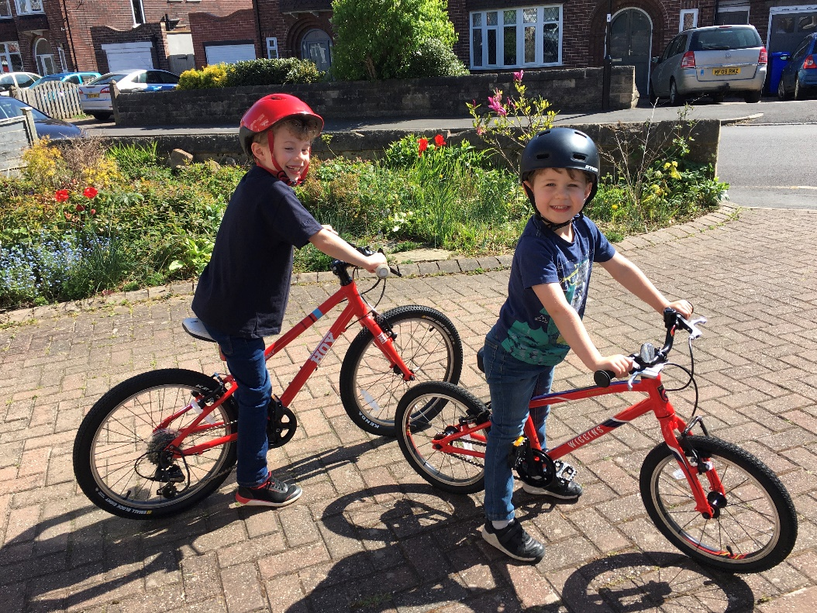
OK. Now we need a fanfare Toot-toot-toot-toot-dah-daaaahhhhh!
WILLIAM HAS LEARNED TO RIDE HIS BIKE WITHOUT TRAINING WHEELS!!!!!
That is truly an amazing thing – you must be feeling very proud of yourself William. Learning to ride your bike is a truly fabulous moment – you can go anywhere now (with mummy and daddy’s permission!) and there will be no stopping you. Freedom!!
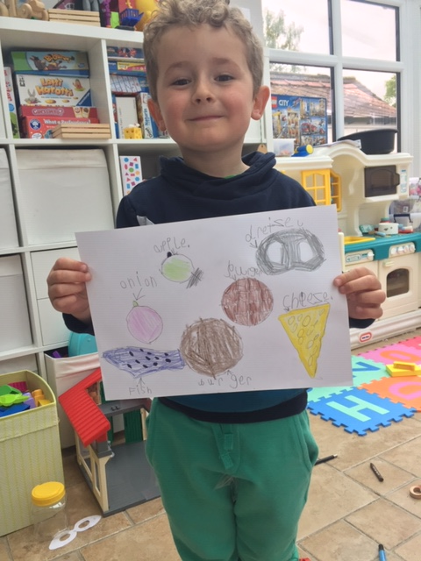
Patrick has drawn some foods – a bit like what the caterpillar ate in The Very Hungry Caterpillar - and he’s written the foods! Great work Patrick! Your writing is so neat and careful. This makes it really easy to read.

I have had a busy week making scrubs. I have been interviewed on the radio (the clip is on the website) and sewn 10 sets of scrubs as well as checking you are all alright, writing reports and being with my family! I also took a break fro sewing on Sunday and I dug a hole in my garden! I found lots of things. I had to wear gloves in case there was any glass in the ground but I found lots of treasure. Want to see?
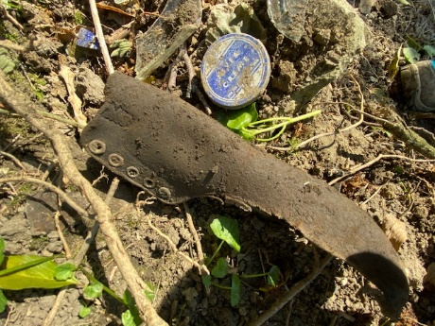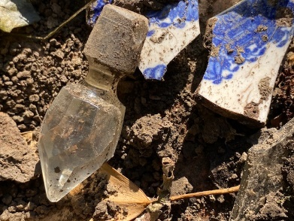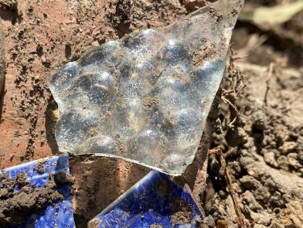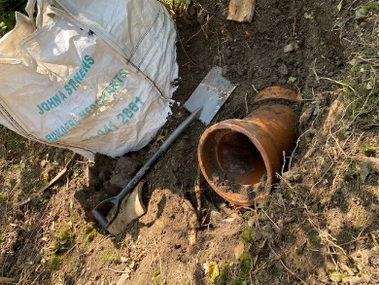
Can you tell what any of these things are?
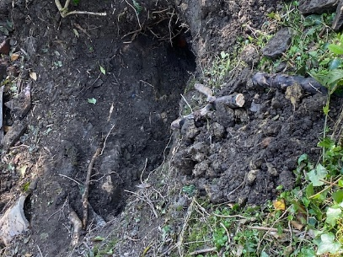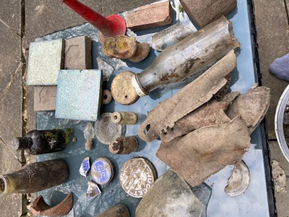
This is the hole that I dug and the museum I made with all the things I found.

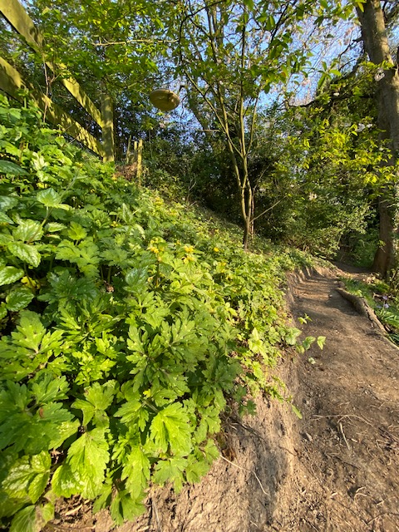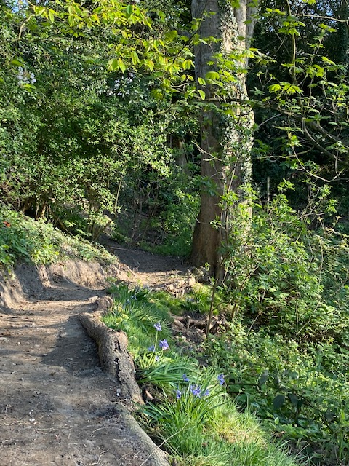
This is the path we’re making in our garden. Its coming on now after lots of digging. I’m hoping I might catch the Gruffalo on it one day!
Ok. That’s all I’ve got for this week. I’ll record another bedtime story on Friday, so check the website then. Be good for your Mummy and Daddy and make sure you help out.

I miss you Rabbits! Stay bouncy!

Love from Mrs F xx

