Summer Term 1: Week 1 20.4.20

Geography task

For your geography task this week, I would like you to have a think about all of the key physical features and key human features that you know about near you.

Key physical features are things in our environment that are naturally occurring. E.g. beaches, cliffs, coastlines, forests, hills, mountains, seas, oceans, rivers, soil, valley’s, vegetation, seasons and weather.
Key human features are man-made features that aren’t naturally occurring. E.g. cities, towns, villages, factories, farms, houses, offices, ports, harbours, shops and schools.

Can you:
- Make a list of all of the key physical features you have near you that you know about? Can you think of examples? E.g. Ecclesalls Woods, River Don etc.
- Make a list of all of the key human features you have near you that you know about? Can you think of any examples? E.g. Whirlow Hall Farm, Dobcroft Infant School, Dore Village etc.

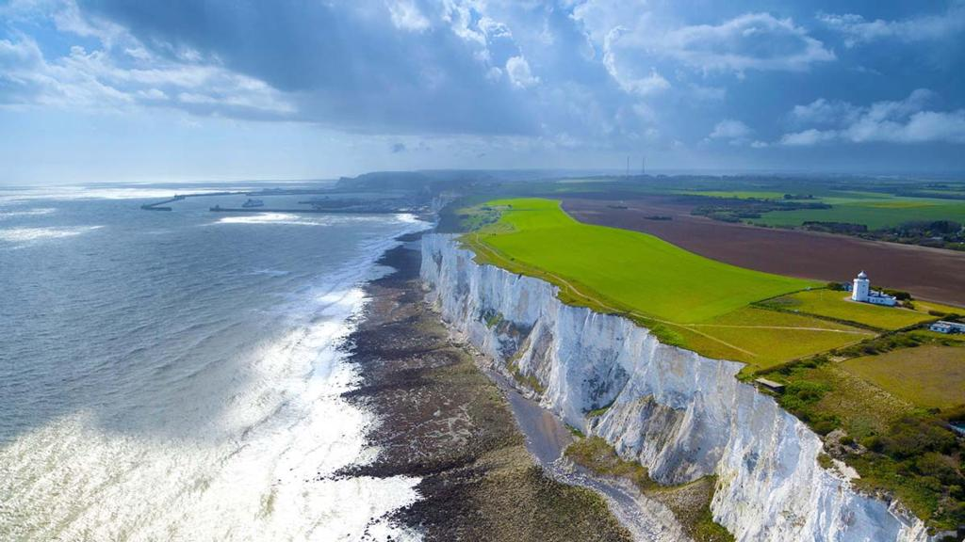

Challenge: From the lists you have made, can you find them on a map or on Google Earth? Can you think of any physical or human features that aren’t near where we live? Can you find them on a map or Google Earth too?

