Summer Term 1: Week 2 20.4.20
English Task 1

Miss Mather has been spending lots of time in her garden over the past few weeks now the sun has been shining. It has been the perfect time to plant some beautiful flowers! This gave her an idea for you to try...

Can you find a set of instructions on how to plant a seed? Or maybe ask an adult at home!

Could you now write your own instructions on how to plant a seed? Let’s see if you can include some imperative (bossy) verbs and underline them in a different colour.

If you have some at home, see if you can follow your instructions now to plant your own seed in the garden and watch it grow into a beautiful flower!

Here are some pictures to give you ideas of the different steps to include.
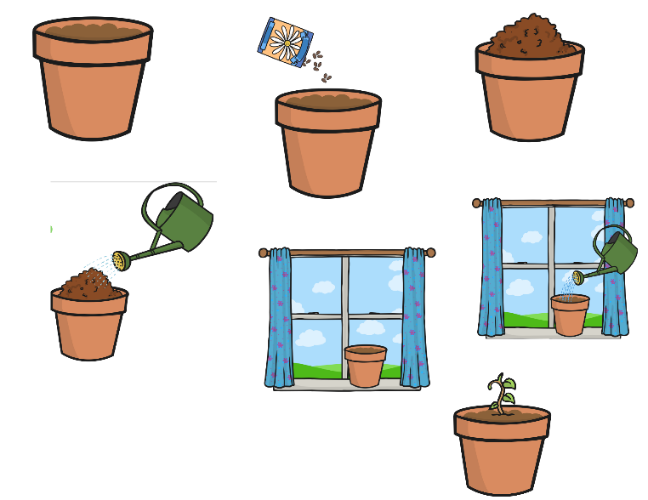

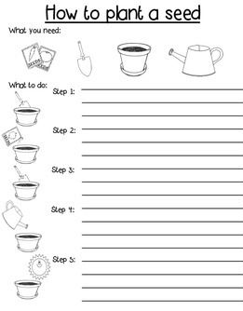

Remember to include all the different features of instruction writing that we have looked at:
- Title
- “What You Will Need” section
- Numbered instructions
- Imperative (BOSSY) verbs
- Pictures and / or a border

