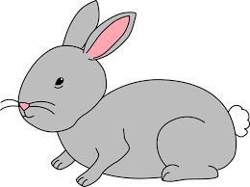
Home Learning Challenge 27/4/20
Challenge 1 – Ordinal Numbers and Positional language
Line up ten of your favourite toys.
Can you answer questions about their position? Who is third in the queue, where is the blue bear etc. (The Blue bear is in 9th place)
Remind your child to answer in a full sentence.
Can you make each toy a label to show their position in the queue?
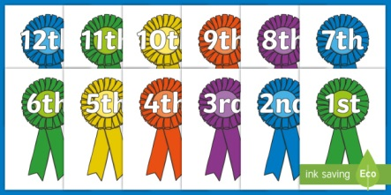
Use positional language in front, behind, between, next to, in the middle to describe the position of the different toys.
Extension
- Practise saying the day and date each day.
Today is Monday 27th April 2020.
- Can you answer word problems involving ordinal numbers …
Stacey came 5th in a race; her friend finished one place in front. What place did her friend finish in?
Mrs Chaudhry came 2nd in the sports day race. Mrs Harrison came two places behind her. Which place did Mrs Harrison finish in?
Challenge 2 – Make a seed packet!
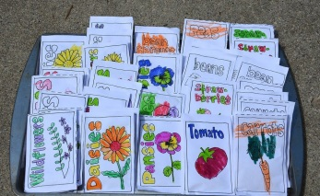
Can you write instructions for planting a seed?
What do you have to do first?
Can you sequence the events in the right order?
Can you write down 6 instructions?
Remember to number your instructions.
Check your work using the writing stars.
Why not write your instructions on the back of an envelope and draw a picture of the plant you would like to grow on the front. You could even put some real or pretend seeds inside!
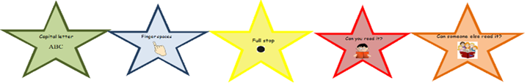
Challenge 3 – Investigate seeds!
Where do seeds come from?
Cut open different fruits and vegetables, can you spot any seeds?
How are they the same/ different?
Can you plant any seeds? What changes to you notice over time?
You could start your own seed diary!
