Summer Term 1: Week 1
Maths Task 4 – half of amounts

A fraction is an equal part of a whole. When we write a fraction we have 2 parts – the denominator and the numerator.

For example; ½ is 1 part of 2 equal parts

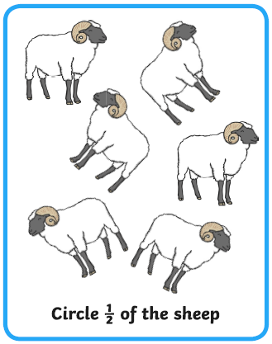
Circle half of these objects.
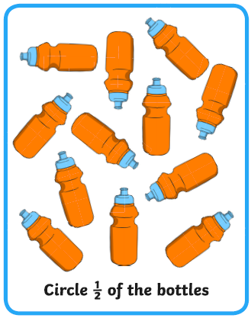
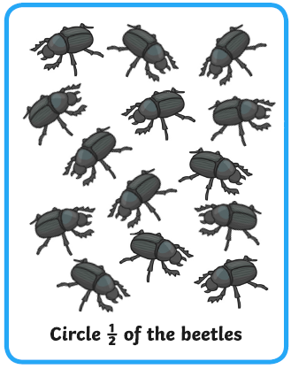

Find half by sharing into the circles.
½ of 12 =

½ of 8 =

½ of 10 =

Now try these:
½ of 20 ½ of 6 ½ of 16

