Summer Term 1: Week 1 14.4.20
English Task 1
We all hope that you have been keeping busy and having fun at home over the last few weeks.
Mrs Machin has kept busy by doing lots of baking and has seen that a lot of people have been too which gave me an idea for an English activity!
If you have done some baking could you write the recipes out as a set of instructions so that we can share your favourite treats with your friends to make?
If you haven’t done any baking, you could give it a go before you write the instructions out.

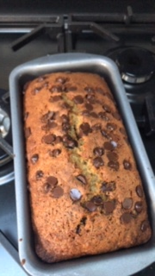
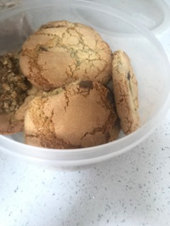
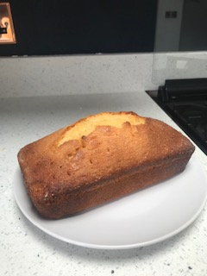
Here are some of the creations Mrs Machin has made for inspiration (baking is not something I find easy!)
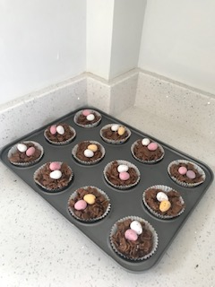

Think back to the instruction writing we have done this year.
Include:
- A title
- What you will need section
- Numbered instructions with ‘bossy verbs’
- Decorate the border with pictures and images of your bake!
