Summer Term 1: Week 1 14.4.20
Reading task

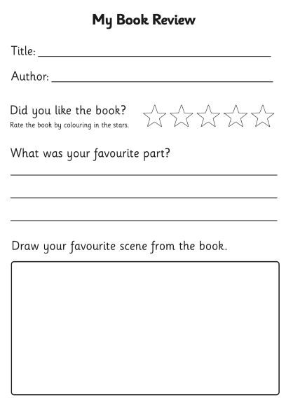
Hello year 2! I hope, like Mrs Holmes, you have been using some of your time at home to get stuck into a good book! What has been your favourite book that you have read recently? Can you write a book review for it?

