ILTP

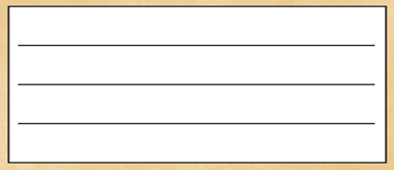Wc 24th Jan



I can write letters in response to sounds I can hear independently.

I can hold my sentence in my head.



I can write red words.

I can write letters accurately

I can work independently

**WANTED**