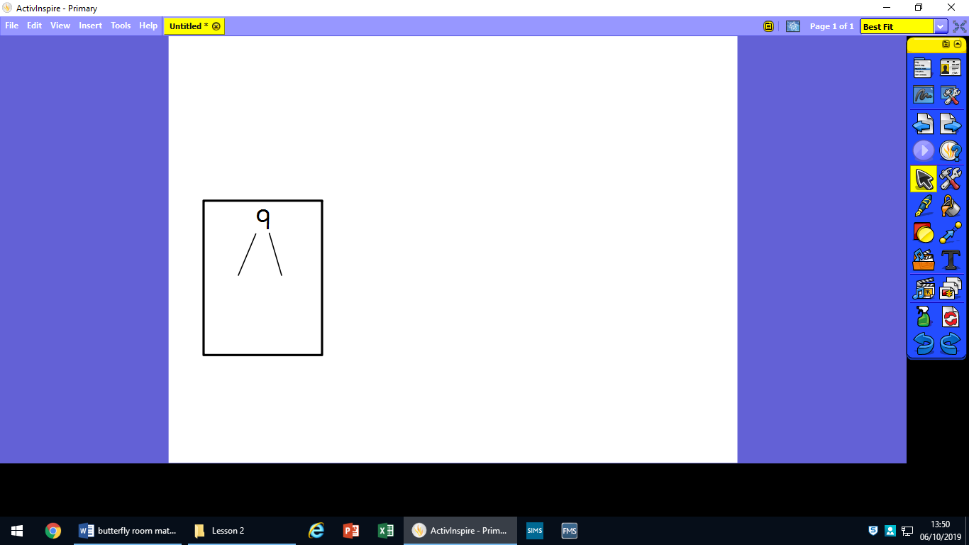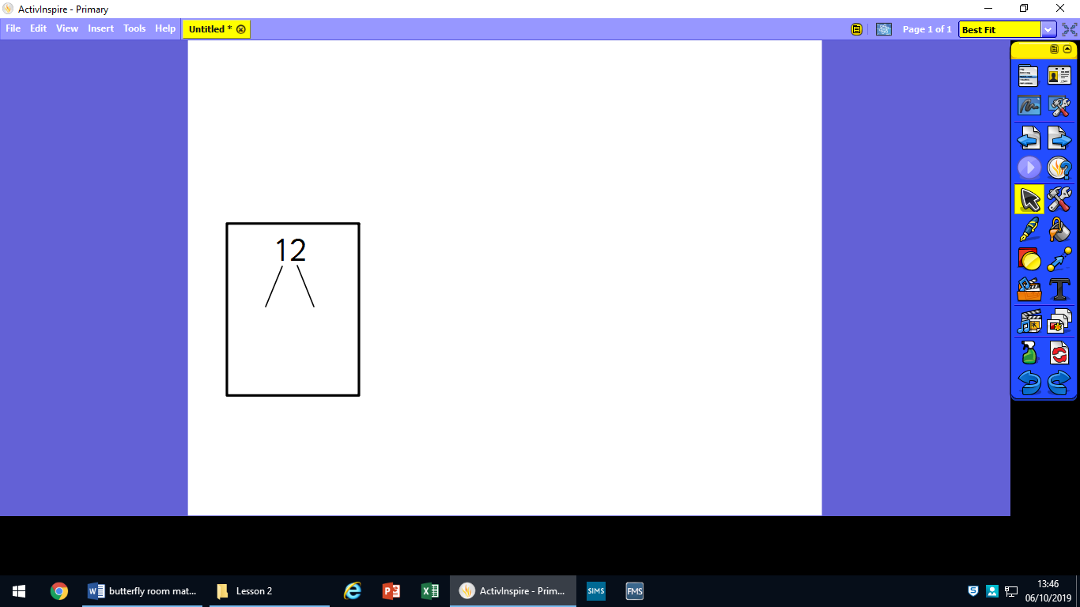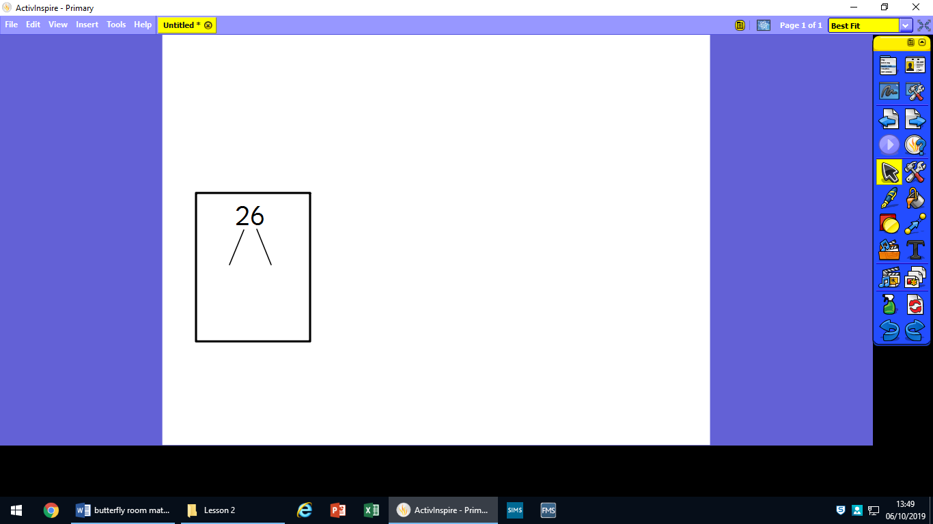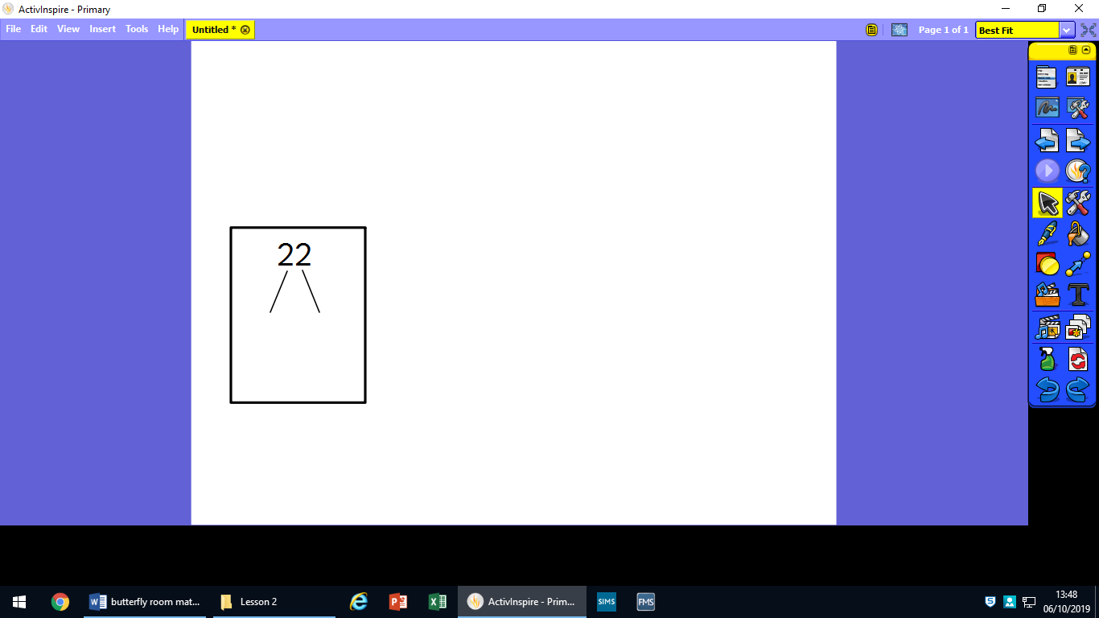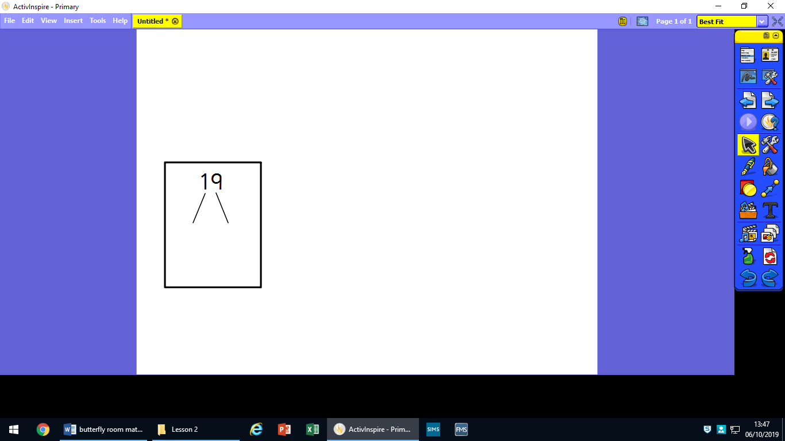Draw out the 10s and ones for these numbers:

33

25

27

10

34

42

**Draw your array for the calculations.**

**One has been done for you.**

**5 x 3 =**

**2 x 4 = 8**

**2 x 3 =**

**3 x 4 =**

**2 x 2 =**

**5 x 2 =**