**Look at the underwater picture.**

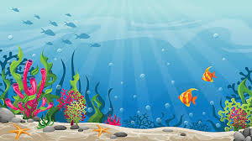Use the nouns, verbs and adjectives table to create some vocabulary for the picture.

|  |  |  |
| --- | --- | --- |
| **nouns** | **verbs** | **adjectives** |
|  |  |  |

Create some expanded noun phrases for the picture.

Then put your expanded noun phrases into compound and comple sentences.

