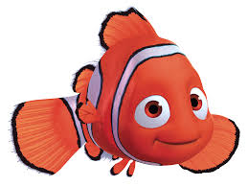
Task 1
Draw a line to match the sentence to the correct function.
What a beautiful place to live
Question
Exclamation
Come back right now
Command
What was Marlin going to do now
Statement
Nemo was an adventurous fish

Task 2
- Write a command sentence that Marlin would say to Nemo.
- Write a statement sentence that describes the character of Bruce the Shark.

Task 1
Draw a line to match the sentence to the correct function.
What a beautiful place to live
Question
Exclamation
Come back right now
Command
What was Marlin going to do now
Statement
Nemo was an adventurous fish

Task 2
- Write a command sentence that Marlin would say to Nemo.
- Write a statement sentence that describes the character of Bruce the Shark.

