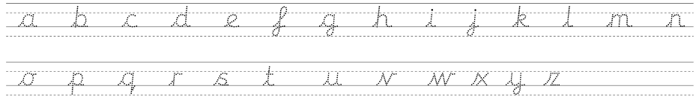





|  |  |  |  |
| --- | --- | --- | --- |
| **adjectives** | **nouns** | **verbs** | **adverbs** |
|  |  |  |  |

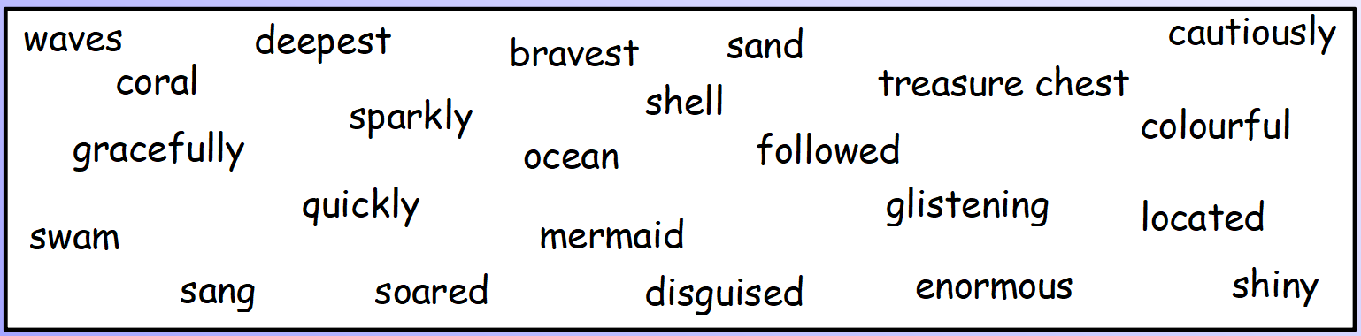

Write some interesting sentences using all of the word types which you could use in your own story.

Can you include different sentence types (compound/complex)?