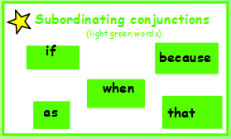
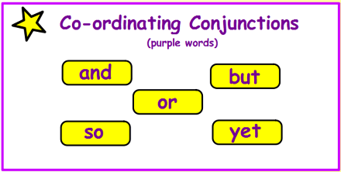

Insert either a coordinating or subordinating conjunction into the sentence so that it makes sense. State whether it is a compound or complex sentence.

- Marlin searched for Nemo he couldn’t find him anywhere.
Compound / Complex

- Dory knew she could save Nemo only she could remember the address.
Compound / Complex

- Nemo was angry at his father he never let him explore the ocean.
Compound / Complex

- Nemo was desperate find his dad he decided to jam the filter.
Compound / Complex

Write a paragraph about a part of the Finding Nemo story that includes a simple, compound and complex sentence.

