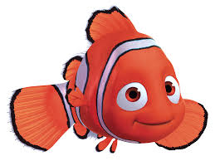**Can you write a character description about Nemo?**

Think about the nouns, verbs and adjectives you could use to help you!

|  |  |  |
| --- | --- | --- |
| **nouns** | **verbs** | **adjectives** |
|  |  |  |