Follow these strategies to help you solve these equations:
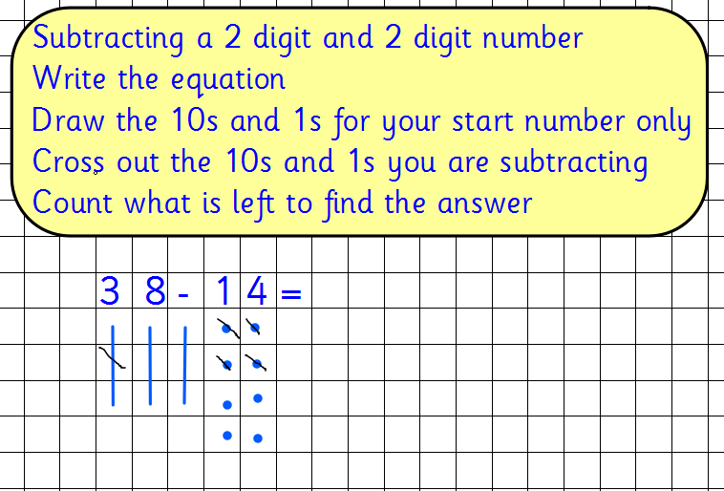
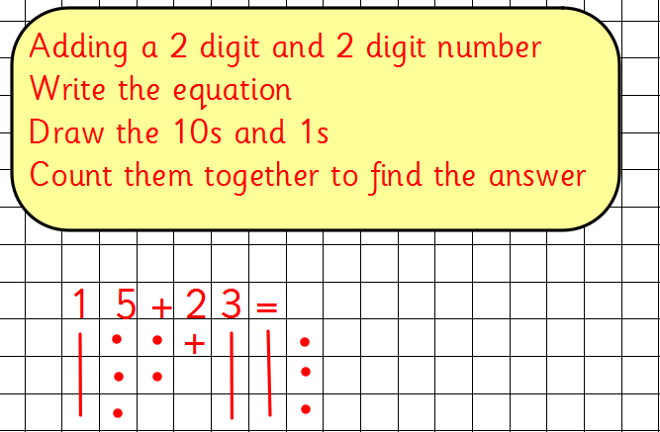

32 + 13 =
25 + 22 =
54 – 31 =
68 – 45 =
71 + 7 =
86 – 43 =
18 + 60 =
39 – 5 =

