

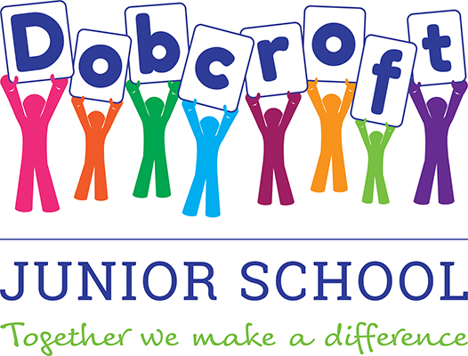



**Infant and Junior Schools**

14th February 2020

Dear parents/carers of children at Dobcroft Infant and Dobcroft Junior School

As you may be aware, the government implemented a new Ofsted framework in September 2019, which included new criteria by which schools are judged. The changes are far reaching and have huge implications for the way schools are inspected and so all schools have been working towards the new framework for some time. As outstanding schools, we are currently exempt from routine inspection[1] but, following the recent General Election, this exemption is being lifted from September 2020 and so we are writing to update you on how we will be inspected in the future.

The four key judgements that make up a school’s overall effectiveness are outlined in the diagram below:

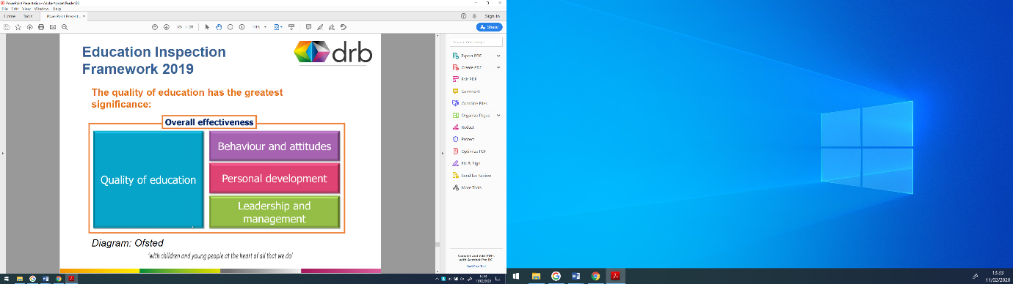

This shift from previous frameworks de-emphasises the focus on pupil outcomes (i.e. test results) in favour of a broader judgement on the Quality of Education. Inspectors will look at outcomes in context and whether they are the result of a coherently planned, well delivered curriculum. As part of the inspection they will select some subjects for closer scrutiny, called ‘deep dives’ which will be conducted alongside the subject leaders. This provides a particular challenge to primary schools as we do not have a head of department for each subject; we rely on class teachers to lead subjects, often more than one. In short, Ofsted will want to see that schools are offering a well thought-out, knowledge-led curriculum. They are looking for a curriculum that promotes mastery of skills by providing a range of opportunities for all children. As schools, we have always prioritised the curriculum offer for our pupils and so welcome this focus.

However, recent inspections have shown that 86% of primary schools previously rated as ‘outstanding’ have now been graded good or lower[2] which presents our schools with a significant level of challenge; ~~we are all~~ both schools are working hard to maintain our ‘outstanding’ judgements.

In addition to the changes on the four key judgments identified above, the criteria upon which inspectors reach their final grade judgements have changed. Previously, conclusions were reached using a ‘best fit’ approach i.e. the inspectors would allocate a grade based on where the majority of statements matched a school’s performance. Under the new framework, judgements are reached by ensuring a school meets all of the available criteria:

*“Outstanding is a challenging and exacting judgement. In order to reach this standard, inspectors will determine whether the school meets all the criteria for good under that judgement, and does so securely and consistently. In other words, it is not enough that the school is strong against some aspects of the judgement and not against others, but it must meet each and every good criterion. In addition, there are further criteria set out under the outstanding judgement, which the school will also need to meet. Our aim in making this change is that schools should only be judged outstanding in a particular area if they are performing exceptionally, and this exceptional performance in that area is consistent and secure across the whole school.”* Ofsted School Inspection Handbook, page 38, para 160.

Parental involvement in an inspection is via the Parent View website and questions have changed to reflect the new framework. You can complete an updated questionnaire at <https://parentview.ofsted.gov.uk/> and this can be completed at any time. Junior school parents were given a paper copy of this questionnaire at this week’s parent’s evening.

We welcome the challenges provided by the inspectorate and will continue to work hard to provide a stimulating education for all the children in our care.

If you have any further questions about school inspection, please do not hesitate to contact us. You can also read the full School Inspection Handbook at <https://assets.publishing.service.gov.uk/government/uploads/system/uploads/attachment_data/file/843108/School_inspection_handbook_-_section_5.pdf>.

Yours sincerely

Cathy Rowland Nicola Sexton   
Headteacher Headteacher   
Dobcroft Infant School Dobcroft Junior School

1. “Maintained primary and secondary schools and academies that were judged to be outstanding in their overall effectiveness at their most recent section 5 inspection are exempt from routine inspections.” Ofsted School Inspection Handbook, p 7, para 16.
2. <https://schoolsweek.co.uk/twofold-rise-in-secondaries-losing-outstanding-rating-under-ofsted-clampdown/>